Part 2

**🗃️** 2. User Memory Section

This is where your program and working data live.

**🧠 What’s stored here?**

*Instructions (Your actual program — logic, sequences, etc.)*

*Application-specific data, like:*

* Current status of inputs and outputs
* Temporary storage for values (like timers, counters, internal flags)
* Recipes, setpoints, operator-entered data

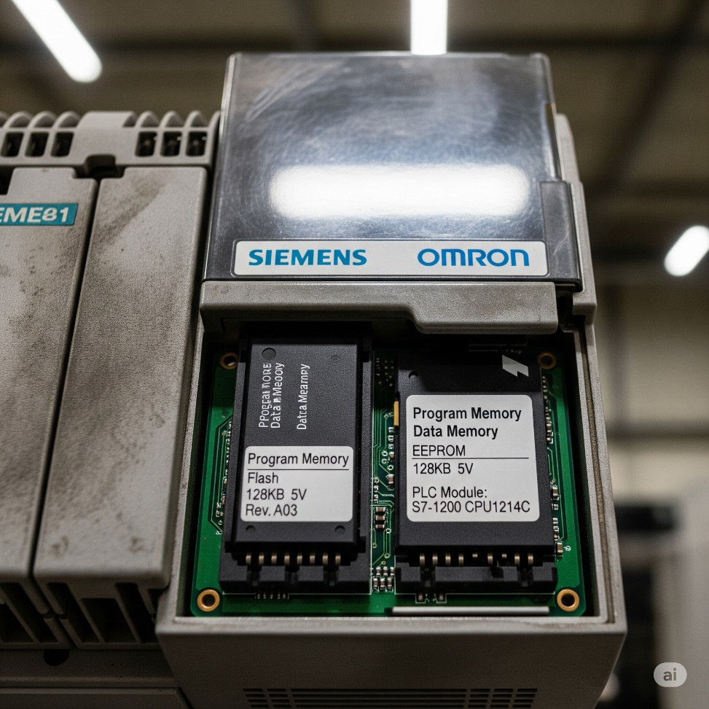

**📝** Real Talk:

If the CPU is the brain, then the **user memory** is like a combo of short-term memory (RAM) and long-term habits (program logic). Your logic tells it what to do, and the CPU keeps checking reality to follow those instructions.

**🧪** Summary with Example Flow

1. Input says: “Tank is full” → sensed by a float sensor.
2. CPU reads this input.
3. It checks your program (user memory): IF tank is full THEN close valve.
4. Decision is made: Close the valve.
5. Output is activated to shut off the valve via a relay/solenoid.

That’s how **industrial automation magic** happens. Simple, logical, powerful.

**🧠** Central Processing Unit (CPU) — The Brain of the PLC part 2

**🗯** Simple Explanation (Teen Mode)

The CPU in a PLC is like the brain of the system. It:

* **Thinks (Decision-Making):** Like deciding, “Hey, the tank is full — I better turn off the water valve.”
* **Remembers (User Memory):** It holds two things:
  1. ***The “how-to” list (instructions you give it).***
  2. ***The “what's happening” info (current readings or values from sensors).***

The CPU does *exactly* what it’s told. If the instructions are dumb, it’ll do dumb stuff — just *very* fast and *very* accurately. It doesn’t ask questions. It just obeys.

**🛠️** Software, Hardware, Firmware — Let’s Demystify This



🔁 The CPU runs two “layers” of code:

* **Firmware**: Low-level code (like an OS) that makes the PLC even *function*. You can't edit this — it’s stored inside the chip.
* **User Software**: Your custom ladder logic or structured text. This is the code that makes your specific plant or machine behave how you want it to.

Just like a PC:

* **Windows 10** = PLC firmware
* **Chrome** = Your PLC program

**💡** Languages the PLC Understands

1. **Relay Ladder Logic (RLL):**
   * Graphical.
   * Inspired by old-school relay schematics.
   * Most beginner-friendly.
   * Looks like electrical diagrams = makes sense to electricians.
2. **Machine Stage Programming:**
   * Think: ladder logic + sequential flowchart.
   * Perfect for machines with stages (like washing machines, bottling lines, etc.).

**🔥** Wrap-Up Quote:

The CPU is not *smart*. It’s *fast*. It's not creative — it's obedient. Give it bad logic, and it’ll mess things up with **machine-level precision**.

🧠 PROGRAMMING A PLC: THE BIG PICTURE

When you hear “PLC Programming,” you're basically talking about telling a small industrial computer (the CPU of the PLC) **what to do and when to do it**. But that involves several components working together:

**🔧** 1.HARDWARE

This is the **physical stuff** — the actual PLC box, the input/output modules, the wiring, power supply, etc.

* **Examples**:
  + CPU (Central Processing Unit)
  + Input/Output modules (for sensors, actuators)
  + Power supply
  + Communication ports
  + Mounting base or chassis

**💽** 2.FIRMWARE

This is the **built-in software** inside the PLC hardware — like its operating system.  
It controls basic operations (scan cycle, timing, comms, etc.) and lives inside a chip.

* **Think of it like this**:
  + **Firmware = Windows for your PLC**, but you can't uninstall or modify it.
  + It's burned into the memory of the PLC (ROM or flash).

**📄** 3.SOFTWARE

This is **your program** — the logic the PLC will execute based on the conditions it reads.  
It’s created by you (the programmer), uploaded into the PLC, and stored in its **user memory**.

* **User memory** stores:
  1. The actual instructions (the program).
  2. Process-dependent info (e.g., sensor values, counters, flags).

**💻** 4.PROGRAMMING TOOLS

You need a device to **write, upload, and monitor** your programs. These are usually:

* **PCs** (modern choice)
* **Handheld programmers** (old-school, niche but still in use)

**⚙️ 5.** PROGRAMMING MODES

There are two ways to interact with your PLC during programming:



***Offline Mode -***This mode is where you do all your initial development, major overhauls, or bug fixes without affecting the live process. It's like working in a sandbox. Changes only exist on your computer. The PLC itself is either running an old program, or if it's new, it has no program at all.

***Online Mode* -** Where you can make small changes to the program without stopping the PLC. This is usually for minor tweaks, debugging or bug fixes. For bigger changes, you'd typically go offline. It's like adjusting your car's mirrors while driving – small, immediate changes.

**💬** 6. PROGRAMMING LANGUAGES

You can't just write English and expect the PLC to understand. It needs **languages it understands**:

a) Relay Ladder Logic (RLL)

* Most common.
* Looks like electrical relay schematics.
* Visual and great for electricians and techs.
* Uses contacts, coils, timers, counters, etc.

b) Boolean Logic

* The math behind all digital logic:
  + AND, OR, NOT, NAND, NOR
  + Often represented graphically in RLL

c) Computer-like Languages (Text-Based)

Some PLCs support structured text, instruction lists, or even Python-like languages. This depends on the brand (Siemens, Mitsubishi, Allen-Bradley, etc.).

**🔥** Bonus Insight: Double Execution in the CPU?

You're **spot on** with this analogy:

**“The CPU handles double work — system stuff (like starting itself) and user programs (PLC code).”**

Yes, the **firmware handles the PLC’s own health and system tasks**, while the **user program runs your logic for controlling the machines**. They coexist but don’t step on each other.

* **Hardware** = physical components
* **Firmware** = pre-installed OS of the PLC
* **Software** = the program you write
* **Programming devices** = PC or handheld (images in the other book)
* **Modes** = Off-line (write), On-line (monitor/test)
* **Languages** = Ladder Logic (visual), Boolean (logic base), or text-based (advanced)

RELAY LADDER DIAGRAM

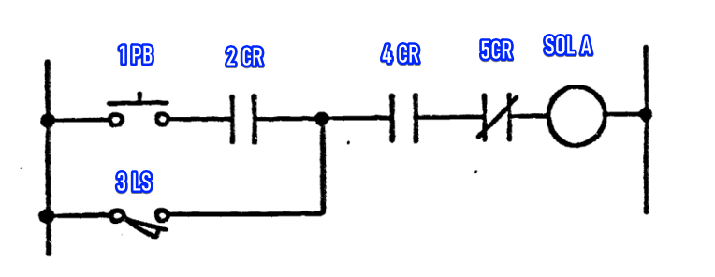

Based on the relay ladder diagram, here's a short description of its components and operation:

This diagram represents a control circuit using rungs and rails, common in industrial automation. There are six distinct components involved in controlling a solenoid.

The six components are:

1. **1PB (Push Button):** This is a normally open (NO) push button. When pressed, it allows current to flow.
2. **2CR (Control Relay 2):** This is a normally open (NO) contact from control relay 2. It closes when control relay 2 is energized.
3. **3LS (Limit Switch):** This is a normally open (NO) limit switch. When actuated, it allows current to flow, providing an alternative path to the 1PB.
4. **4CR (Control Relay 4):** This is a normally open (NO) contact from control relay 4. It closes when control relay 4 is energized.
5. **5CR (Control Relay 5):** This is a normally closed (NC) contact from control relay 5. It opens when control relay 5 is energized, interrupting the circuit.
6. **SOL A (Solenoid A):** This is the output device, a solenoid, which is activated when current flows through it.

In operation, Solenoid A will energize if either the 1PB is pressed AND 2CR is closed, OR if the 3LS is actuated.

Additionally, for the solenoid to energize, 4CR must be closed AND 5CR must NOT be energized (meaning its normally closed contact remains closed).

Essentially, it's a logic circuit where multiple conditions must be met in sequence or parallel for the solenoid to activate.



**🧠** First: YES — Electricity flows left to right in a ladder diagram.

* Just like a book, ladder diagrams are read from **top to bottom** and **left to right**.
* The **left vertical rail = L (Live)**
* The **right vertical rail = N (Neutral)**
* Current flows **from L to N** through the rungs — same way logic flows.

**🧩** Now: Let’s decode the mystery around 5CR

You're 100% right to question:

*“Doesn’t the current still have to go through 5CR? So how can you say '5CR must not be energized'?”*

This is where **ladder logic’s secret sauce** kicks in — the concept of **contacts being “controlled” by other relays or coils**.



We gotta separate two things cleanly:

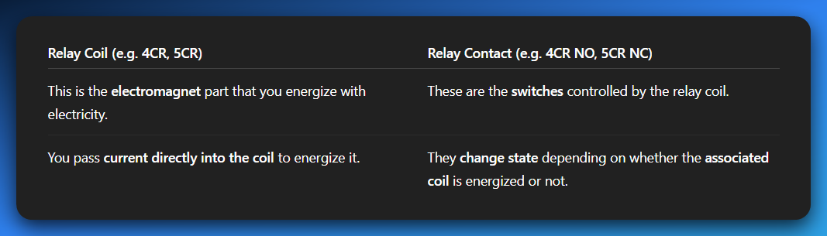



Let’s expand on that a little bit more…



**👇 Back to Your Circuit:**

Let’s say you have:



Here’s what matters:

4CR and 5CR are not actual wires or power routes.

They're **contacts** controlled by relays **somewhere else**.

You’re not "passing electricity **through** a relay coil." You're passing electricity through **relay contacts**.

🔄 So when you close the 4CR relay, it energizes its **own coil**, and **its own contacts change** wherever they are.

✋ But if there's a **5CR NC contact** in that rung, whether it allows current or not **depends on the state of 5CR's coil**, **not** on the current coming from 4CR.

In short:

* **You’re not passing current into 5CR coil here.**
* You’re passing through the **contact** controlled by 5CR.
* So, if 5CR is energized **somewhere else**, its NC contact becomes **open**, breaking the circuit.

**✅** The Key Takeaway:

*Current doesn’t change a contact's state just by “passing through it.”*

A contact changes state **only when its matching coil is energized**.

If you're going through a 5CR contact, its state depends only on whether **5CR’s coil** is energized.

**🔄** So your thought:

*“Since it must pass through 5CR, doesn’t it automatically open?”*

❌ **Nope.** It opens only if the 5CR relay coil is energized. Otherwise, it stays in its default state (normally closed or normally open).

**💡** Analogy (Gen Z mode):

Think of it like **smart home lights**.

* 4CR is a smart bulb. You control it with your phone (energize the coil), and it lights up (closes the contact).
* 5CR is another smart bulb, but its switch is somewhere else.
* Just because you're sending power to bulb A doesn't mean bulb B will react — unless **its own switch (coil)** is triggered.

**👀** Bonus: Physical vs Ladder Logic

In real-world relays:

* **The contact is just a mechanical switch** inside a relay block. No power goes *through* a relay coil by just touching a contact.
* You energize a coil -> internal switch flips -> your circuit reacts.

**✍️** Bottom Line:

🔌 Electricity **through a contact** ≠ electricity **through a relay coil**

🧠 Contacts change state only if their **relay coil is energized**.

So, your 4CR energizing doesn’t affect 5CR unless there’s a link somewhere in the logic to **energize 5CR’s coil**.

**💡** The BIG mistake students and teachers make:

**🔌** There are two things going on with a relay:

1. **The coil** (e.g., 4CR or 5CR coil) – when energized, **it changes the state** of that relay’s contacts.
2. **The contacts** (NO or NC) – are just **switches** that open or close **based on whether the coil is energized**.

Mistake? Thinking **current “passing through” a contact** changes its state.

**FALSE.** The contact's state **is not changed** by current *passing through* it — its state is only changed if the **coil** tied to it is energized.

**🧠** Example Walkthrough:

Let’s say we have:

* 4CR coil (controlled by some condition)
* 5CR contact (let’s say it’s a Normally Closed [NC] contact)

And 4CR's current is flowing **through** that 5CR contact. Here's what matters:

* If **5CR coil** is **not energized**, the contact **stays NC** → current flows normally.
* If **5CR coil** **is energized**, then and only then does its contact **open** → breaking the path.

➡️ The relay **contact is just a puppet.**  
➡️ The relay **coil is the puppeteer.**

**🔁** Don't Mix Up These Two:

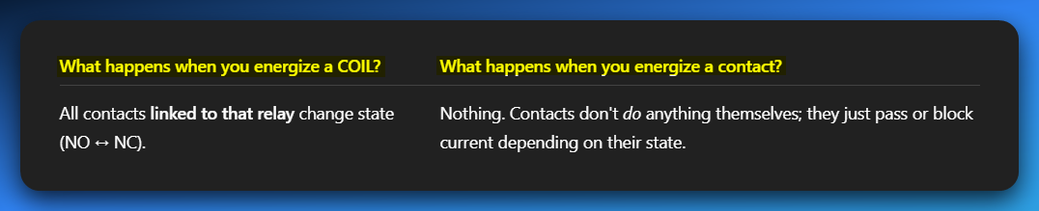

**🔧** Final Nail:

If current goes through a contact — **that does not change the contact.**  
The only thing that **changes a contact’s state** is **the COIL of that same relay being energized**.

**💬** You Said:

*“Doesn’t current already pass through 5CR so it becomes open contact?”*

**NOPE.**  
That’s where it tripped you up. The 5CR contact will only become open if the **5CR coil** is energized — not because current passed through it.

**🎯** Burn this in your memory:

**“Coil controls the contact. Contact does not control the coil.”**

FREE FORMAT EQUIVALENT PC DIAGRAM FOR THE SAME IMAGE DISCUSSED?



BOOLEAN STATEMENT?



CODE OR MNEMONIC LANGUAGE?



🔧 PLC Programming Languages — Comparison Table

**Ladder Logic (LD)** is the most commonly used language in PLCs, especially in standard industrial applications. It resembles electrical relay diagrams, which makes it intuitive for electricians to understand and troubleshoot.



**Function Block Diagram (FBD)** is often used in automation-heavy systems. It allows users to drag and drop logic blocks, making it especially appealing to visual thinkers who prefer graphical representations of control logic.



**Structured Text (ST)** is typically used in advanced control systems. It resembles the Pascal programming language and is best suited for applications involving complex logic or mathematical operations.



**Instruction List (IL)** is largely obsolete in modern PLCs. It is a low-level language that resembles assembly code. While deprecated, it may still be encountered in older systems.



**Sequential Function Chart (SFC)** is ideal for batch processes. It is designed to represent step-by-step workflows using a visual state machine approach, making it excellent for modeling sequential operations.



**🚨 TLDR**: *Ladder Logic is king* because plant technicians already know relay circuits. Familiar = faster = fewer errors.

**🤖** PLC vs. Traditional Control Systems

PLCs dramatically outperform traditional relay systems in every key area—including flexibility, reliability, data collection, expandability, repeatability, and space efficiency—making them the clear choice for modern industrial control. 

**💻**PLC vs. Personal Computers (PCs)

PLCs are purpose-built for the brutal realities of industrial environments. PCs, while powerful, just can't hack it when things get tough…💪



**🧠** Electrical Specs of a Sample PLC Power Supply:

* **Voltage Input Range**: 85–132V or 170–264V AC
* **Frequency Range**: 47–63 Hz
* **Input Current**: ~1.3A
* **Inrush Current**: Max 20A (short burst)
* **Input Power**: ~50W
* **Output Voltage**: 5.1V ± 0.25V (low ripple)
* **Ripple**: < 100mVp-p
* **Output Current**: Ranges 0.1A – 3.7A depending on voltage

📎 *Basically, PLCs are built to work in factories, next to loud motors, heat, vibration, electrical spikes… PCs would be crying in a corner.*



Summary Box:

🧠 **Why Pick PLCs?**  
Because they’re *optimized for the real world*. They’re not fragile, fussy computers. They're reliable, rugged, and repeatable — and they speak the language electricians already know: ladder logic.

**💻**PLCs vs. Computers & PCs (Part B: Software + Programming)



🛠️ Part C: Maintenance Comparison – PLCs vs PCs

PLCs win big on maintainability and ease of integration for industrial settings. They're designed for quick fixes by on-site teams, minimizing downtime.



**🧠** Quick Summary: Why PLCs Win in the Factory

* They **diagnose themselves**.
* Use **relay-style logic** so any technician can understand.
* **Handle harsh environments** without crying.
* Can **run 24/7** with minimal maintenance.
* PCs may be smarter, but **PLCs are built tougher** for plant floors.

PLC Sizes and Their Applications (Simplified & Upgraded)

**🔢** 1. Understanding PLC Size Categories

PLCs come in different “sizes” — not physically, but in terms of memory, input/output capacity, and what kinds of tasks they can handle.

Think of it like phones: a basic **flip phone** vs. a **midrange Android** vs. a **flagship iPhone** **Pro Max.**



**💾**2. Memory Tech Used in PLCs

PLCs rely on specific memory types to keep their programs running, even when the power flickers. Here's a quick look at the key tech.



Here’s a realistic sample…



3. PLC Size, Complexity, and Cost Relationship



**Quick Notes on PLC Sizing:**

* **I/O Count (X-axis):** This is like the number of "ports" or connections your PLC has for sensors and actuators. More I/O means it can control more stuff.
* **Complexity & Cost (Y-axis):** As you move up, the PLC can handle more intricate tasks and, naturally, costs more. Think of it as going from a basic smartphone to a high-end server.
* **Boxes (A, B, C, D):** These represent different PLC categories (Small, Medium, Large) and show that as I/O count increases, so does the complexity it can manage and its price.
* **The Trend:** The chart clearly shows an upward trend – bigger PLCs handle bigger jobs and come with a bigger price tag.

*Just like upgrading your gaming rig, the more "muscle" (I/O count) a PLC has, the more complex tasks it can handle, and yep, the higher the price tag. This chart shows that sweet spot.*

🔗 3. Scope of Applications



**🤖** Bottom Line (Real Talk)

* **Small PLCs**: Like using a calculator — great for simple math, not TikTok edits.
* **Medium PLCs**: Your daily driver — handles most tasks without crying.
* **Large PLCs**: Supercharged server-tier boss mode — can run a whole factory and still chill.

**💡** PLCs Usability Benefits + Practical Benefits Table

Let’s go beyond marketing fluff and break it down: *Inherent Features of PLCs*

* **Solid-State Components (no moving parts = fewer failures)**
* **Programmable Memory (non-volatile, editable logic)**
* **Compact Size (small footprint)**
* **Microprocessor-Based Operation (real-time logic control)**
* **Built-in Timers/Counters**
* **Software-based relays (replace physical hardware)**
* **Modular Architecture (easily swappable modules)**
* **Multiple I/O Interfaces (digital, analog, remote)**
* **Remote I/O Stations (connected via coax/twisted pair)**
* **Real-Time Monitoring & Diagnostics**
* **User-editable memory and logic**



PLC MEMORY AND DATA REPRESENTATION

**🧠** Understanding PLC Memory & Data Representation

When working with PLCs, it's crucial to know how they store and interpret data. At their core, PLCs **don’t “see” numbers or words** the way humans do — they see **voltage levels**, **binary digits**, and **memory addresses**.

**🧩** 1. What Does a PLC Store?

PLCs handle two main categories of data:



🔍 Think of it like this: instructions = the brain’s to-do list, process data = the brain’s current awareness of the environment.

**⚡** 2. How Is This Data Stored?

Unlike us, who use **decimal numbers (0–9)**, a PLC stores data using **binary (0 and 1)** — not just for fun, but because it physically uses **electrical signals** to represent these states. 

💡Inside the PLC’s memory chips (RAM or ROM), data is stored as millions of tiny switches that are either ON (1) or OFF (0), represented by voltage levels.

**🧠** 3. Human vs. PLC Perspective

Let’s take a real-life example:  
You want the PLC to keep track of how many **cans** were counted.

👨 Human:

You think in decimals:  
**"24 Cans"** → makes sense to you.

🤖 PLC:

It can’t store “24” as-is. It converts it:

* Decimal 24 → Binary 00011000
* Each binary bit gets mapped to voltage:  
  0 → 0V, 1 → 5V



📌 *This is how the PLC internally “thinks” about the number 24.*

**🧰** 4. Why This Matters in Practice

* You’ll often **see, debug, and manipulate** data in its **binary** or **hex** form inside the PLC. Understanding this voltage-level mapping helps when working with:
  + **Input/Output signals**
  + **Timers/Counters**
  + **Word/Bit-level instructions**
  + **Data type conversions (BCD <-> Binary, etc.)**

🔄 *Binary ↔ Decimal conversion is your daily bread in PLC land. Don't skip it.*

**📸** Visual Breakdown (Explained)

Imagine this image setup:

* **Left side**: A person is thinking “24 cans”
* **Right side**: A PLC's thought bubble showing: **0V 0V 0V 5V 5V 0V 0V 0V**

*This diagram is not just cute — it teaches you the mental translation process:*

*Human-friendly data → PLC-friendly voltage signals → Actual binary bits in memory*



**✅** Summary Cheat Code



The last one is a bit tricky…

**For us**, numbers, words, and concepts carry inherent meaning. "24" immediately means a quantity, an amount, something we can understand and relate to. Our brains are wired for abstract thought and interpretation.

**For a PLC**, there's no "meaning" in the human sense. It's all about physical electrical states.

**🔢 What Are Numbering Systems in PLCs?**

**💾 Data in PLCs = Either Instructions or Process Info.**  
But here's the catch: *PLCs don't "think" in decimal.* Humans type numbers in base-10 (like 25 or 90) — but PLCs store them in **binary** using 1s and 0s.

So… **translation is needed** between human-readable numbers and machine-level binary.

**🧠** Binary Number System (Base-2)

* **Only 2 digits:** 0 and 1.
* These are called **bits.**
* Groupings:
  + 1 bit = 1 binary digit (duh)
  + 4 bits = **Nibble**
  + 8 bits = **Byte**
  + 16 bits = **Word**
  + 32 bits = **Double Word**

Each bit in a binary number has a weight — just like place values in decimal — but in **powers of 2**.



**🧮** Convert Binary to Decimal

Steps:

1. Start from the right.
2. Only look at positions that have a 1.
3. Add their **weight** (the column value).

🧠 Example:



That’s how the PLC remembers it — as 00110010. But when you check on your HMI or software, it’ll show **50** in decimal.

**🔟** Decimal Number System (Base-10)

* Humans use **10 digits**: 0 through 9
* Each digit has a place value weighted in powers of **10**

Example:



The concept of **weighted columns** exists in both decimal and binary.  
The difference is that:

***Binary → Powers of 2***

***Decimal → Powers of 10***

**🧠** Why Does This Matter in PLCs?

Because whenever we:

* Type a value into the PLC
* Store a sensor reading
* Set a timer

…The PLC stores it in binary, but you *see it* in decimal.

Understanding how those 1s and 0s are turned into human-friendly numbers helps you:

* Debug logic better 💻
* Spot errors quickly 🕵️
* Know how memory is being used 🧠

PLC Numbering Systems + Data Types Simplified

**🚀** BIT, BYTE, WORD — What’s What?



✅ In PLCs:

* 16-bit word = max value **65535** (if unsigned)
* 32-bit word = up to **~4.2 billion**

Word length determines how big a number your PLC can store or calculate.

**🧮** Numbering Systems Recap

Let’s blitz through these like a pro:

1. Binary (Base-2)

* Digits: 0 and 1
* Every bit = power of 2
* Used **internally** in PLC memory & logic

🧠 Example:



2. Octal (Base-8)

* Digits: 0–7
* No 8 or 9 exists!
* Some old-school PLCs (like Allen-Bradley) used **octal addressing** for I/O: 001, 002, ..., 007, 010 (which is 8 in decimal).

🧠 Rare today but *still shows up* in legacy systems.

3. Decimal (Base-10)

* Digits: 0–9
* What humans use by default.
* PLC HMIs show **decimal**, but store as **binary** internally.

4. Hexadecimal (Base-16)

* Digits: 0–9 and A–F
  + A = 10
  + B = 11
  + ...
  + F = 15
* Shorter than binary but stores the same info
* Used heavily in:
  + **Timer values**
  + **Memory locations**
  + **Comms settings**
  + **Hex instructions**

🧠 **Example:**



5. BCD (Binary-Coded Decimal)

* Each decimal digit is stored separately in binary
* e.g., 45 = **0100** **0101** (not 00101101)
* Used in:
  + Thumbwheel switches
  + Old school panels
  + PLCs that interface with operator input modules

BCD is weird but still lingers in industrial gear.

**🔁** Conversions You’ll Actually Use:



You rarely convert octal or BCD manually, but binary/hex/dec happens *daily* in ladder logic debugging and SCADA.

**🚨** Max Values Recap



**🎯** What’s New Here for PLC-Specific Context?

* **PLC I/O addressing might use Octal or Hex** (e.g., Address 020 in Octal is not 20 in decimal—it’s 16!)
* **Timers/Registers** often appear in **Hex** in programming software
* **Memory** segments are word- or byte-addressed, so knowing limits (8-bit/16-bit) = less debugging rage 😤

🔥 HEX & DECIMAL CONVERSIONS

🧠 First, the Big Idea: Place Value Table

Just like decimal (base 10) uses powers of 10, hexadecimal (base 16) uses powers of 16.



Shows the comparison between decimal (10ⁿ) and hexadecimal (16ⁿ) place values.

When we say **"1st from the right"**, **"2nd from the right"** and so on, we are talking about the position of a digit in a number, starting with the rightmost digit as the first position.

Think of it like reading numbers. In the number 1234:

* 4 is the **1st from the right** (the ones place).
* 3 is the **2nd from the right** (the tens place).
* 2 is the **3rd from the right** (the hundreds place).
* 1 is the **4th from the right** (the thousands place).

This applies to any number system, whether it's decimal, hexadecimal, or binary – you always count positions starting from the rightmost digit and moving left.

**✨** Convert Hex to Decimal – Easy Mode:

You multiply each digit (starting from the right) by powers of 16, then add them all up.

💡 **Pro tip:** A-F in hex = 10-15 in decimal - A = 10, B = 11, C = 12, D = 13, E = 14, F = 15

Section 2: Example 1 - 3F9₁₆ to decimal



Example 2: AF1C₁₆ → 44,828₁₀



Example 3: 3B8D2₁₆ → 243,922₁₀



**🔄** Decimal to Hex: Division and Remainders

This is like reverse engineering. You divide by 16 repeatedly, collecting **remainders**. These remainders (in reverse order) give you the hex value.

**💻** Example: Convert 493 to Hex

Step-by-step:



💻 Example: Convert 57392 to Hex



How the Division Method Works



**🧠** Final Boss Trick: Why Hex is **🔥**

* **Compact**: 1 hex digit = 4 binary bits. Clean.
* **Readable**: Easier to debug than long binary strings.
* **Popular**: Memory addresses, opcodes, machine-level data—hex runs the show.



**🧠** LOGIC CONCEPTS - SUBTOPIC: BOOLEAN ALGEBRA

**📜** Quick History Drop

* **Year:** 1849
* **Inventor:** George Boole (England)
* **Why it matters:**  
  He created a mathematical way to describe logic—like "If A is true, then B must be false."  
  Every digital circuit, from your calculator to a PLC to an Intel CPU, is built on his rules.  
  This isn't just dusty philosophy—it *runs the world.*

**🔌** The Core of Boolean Algebra

* It's a way to write **logic expressions** (decisions, conditions) that can only be **True or False**.
* In digital electronics:
  + **True = 1**
  + **False = 0**
* Called a **two-valued (binary) system.**

**📐** Why Use Boolean Algebra in PLCs?

Because ladder logic *is literally* Boolean logic in disguise:

* A contact closed? = 1
* A coil energized? = 1
* Two conditions in series? = AND logic
* Two in parallel? = OR logic

**✅** Boolean Operators (The Building Blocks)



AND Gate



Both A and B must be 1.

OR Gate



Either A or B must be 1.

NOT Gate



Opposite of the value. Flips it.

🧾 7 Main Boolean Laws (Clean Version)

Master the fundamental laws that govern Boolean algebra - the building blocks of digital logic! 🚀

1. Commutative Laws

* **A + B** = **B + A** (OR doesn't care about order)
* **A · B** = **B · A** (AND doesn't care about order)

 

Just like 2 + 3 = 3 + 2 in regular math, Boolean operations don't care about the order of inputs!

2. Associative Laws

Grouping doesn't change the result.

You can group operations however you want - the parentheses can move around freely!

 

Parentheses can group operations differently without changing the result –

(2 + 3) + 4 = 2 + (3 + 4)!

3. Distributive Laws

Like algebra with a logic twist.

You can distribute operations across parentheses, just like in regular algebra!

 

You can 'distribute' one operation across another, just like a(b + c) = ab + ac in algebra!

The dot doesn’t mean anything, just multiply. That’s why it could be written as above highlighted in yellow. **AND** means multiply. **OR** means addition. Have that in mind.

4. Identity Laws

0 is the identity for OR, 1 is the identity for AND.

These are the 'do nothing' operations - they leave values unchanged!

 

These values don't change the result - like multiplying by 1 or adding 0 in regular math!

In boolean algebra, **"Identity Laws"** describe **"do nothing"** operations.

For the **OR operation** (represented by +), adding 0 to any value A keeps A unchanged (e.g. A + 0 = A), just like adding zero in regular math.

For the **AND operation** (represented by • or multiplication), multiplying any value A by 1 keeps A unchanged (e.g., A • 1 = A), similar to multiplying by one in regular math.

These specific values, 0 for OR and 1 for AND, are called **"identities"** because they don't alter the original input.

5. Null Laws

1 in OR dominates, 0 in AND kills everything.

These are the **'dominating'** values that override everything else!

 

These values **completely dominate** the result, no matter what the other input is!

6. Involution Law

Double negation cancels out.

Two NOTs make a positive - just like in regular language!



Two negations cancel each other out - 'It's not true that it's not raining' means 'It's raining'!

7. Complement Laws

A variable with its opposite.

When you combine a variable with its opposite, you get predictable results!

 

A variable combined with its opposite gives predictable results - something can't be both true AND false!

*Simple, isn’t it? These 7 laws are the foundation of all digital logic. You're now ready to tackle any Boolean algebra problem!* 🎉

*Let’s quickly do the truth tables for these Logic Gates and then we shall jump straight into PLCs. All this was just an introduction, laying the groundwork.*

LOGIC GATES

The Building Blocks of Digital Logic

Welcome to the most epic logic gates journey ever! We'll master the triple threats (AND, OR, NOT) and then dive deep into the advanced squad! 🚀

1. AND Gate

Output is 1 only when BOTH inputs are 1.

**Boolean Equation:**



**PLC Application**

Motor runs only when START button is pressed AND safety guard is closed.



**🌍 Real World Example**

Car engine starts only when key is turned AND seatbelt is fastened.

2. OR Gate

Output is 1 when AT LEAST ONE input is 1.



**PLC Application**

Alarm sounds when temperature is high OR pressure is high.



**🌍 Real World Example**

Room light turns on from wall switch OR bedside switch.

3. NOT Gate

Output is the OPPOSITE of the input.



**PLC Application**

Conveyor stops when emergency stop button is NOT pressed.



**🌍 Real World Example**

Security light turns ON when motion sensor is OFF (no motion).

4. NAND Gate

**NOT-AND:** Output is 0 only when BOTH inputs are 1.



**PLC Application**

Safety system triggers unless BOTH sensors detect normal conditions.



**🌍 Real World Example**

Car alarm is OFF only when key is in AND door is locked.

***If A or B is false, then Q is true.***

5. 3-input AND





4. NOR Gate

NOT-OR: Output is 1 only when BOTH inputs are 0



**PLC Application:**

System is safe only when NO faults are present.

**🌍 Real World Example:**

Safe opens only when NEITHER alarm is active NOR motion is detected.

5. XOR Gate

Exclusive OR: Output is 1 when inputs are DIFFERENT.

**Boolean Equation**



**PLC Application**

Parity checker: output is 1 when odd number of 1s.

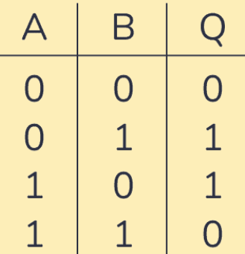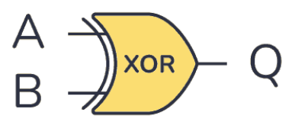

**🌍 Real World Example**

Stairway light: either upstairs OR downstairs switch (but not both).

* **Binary Addition**: XOR gates are used in half adders and full adders to perform binary addition of two bits, producing the sum bit.
* **Parity Generation and Checking**: XOR is employed to generate and check parity bits, ensuring data integrity by verifying whether the number of 1's is odd or even.
* **Data Encryption and Decryption**: XOR is widely used in cryptographic algorithms, where it combines data during encryption and reverses the process during decryption.
* **Digital Signal Processing (DSP)**: XOR gates are used in signal processing applications, such as modulation, demodulation, and noise shaping in audio systems.
* **Generating Random Numbers:** XOR gates are often part of pseudorandom number generators in digital systems, contributing to the creation of random sequences.
* **Bitwise Comparison:** XOR is used for bitwise comparison, highlighting positions where two binary numbers differ.
* **Error Detection and Correction:** XOR plays a key role in error-detecting and error-correcting codes like Hamming code, allowing for identification and correction of single-bit errors.
* **Parity Bit in Memory Storage:** XOR gates are involved in computing and verifying parity bits in memory cells, ensuring data consistency and error correction.

6. XNOR Gate

Exclusive NOR: Output is 1 when inputs are the SAME.

**Boolean Equation and Logic Gate**



**An XNOR** **gate** produces a high output (1) only if its two inputs are equal. Commonly used in digital circuits to perform arithmetic and data processing operations.



***If A and B are the same, then Q is true.***

**PLC Application**

Quality control: pass when measurements are equal.

**🌍 Real World Example**

Garage door: opens when remote signal MATCHES security code.

BOOLEAN TO LADDER LOGIC CONVERSION



The Building Blocks of Logic

Think of these diagrams as a series of instructions that a machine follows, one line at a time. It's like a simplified programming language where everything is either "ON" or "OFF."

**🧠** Think of Ladder Logic like Industrial Pseudocode

Ladder Logic is basically **visual code** where each rung is a logic statement:

* It runs **top to bottom, left to right**—just like reading a book.
* Each rung is like:  
  if (condition) → then (do something)
* And everything is **binary**—either ON (true, 1) or OFF (false, 0).  
  Let’s break down the pieces.

**🔌** Contacts = The If-Checks

Contacts are your conditional checks. They read inputs from switches, sensors, or internal memory bits.

1. Normally Open (NO) Contact: | |

A Normally Open contact is like a gate that starts **closed** (blocking the path). For electricity to flow through it, something must happen first to **open the gate**.

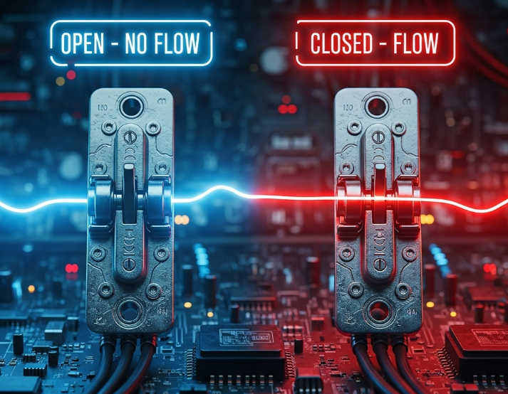

How It Works

* **Normal state:** The contact is OPEN = No electricity flows through
* **When activated:** The contact CLOSES = Electricity can flow through
* **Think of it as:** A switch that must be turned ON for power to pass

Real World Example: Coffee Machine Start Button

Imagine the start button on your office coffee machine:

* **Normal state:** Button is not pressed → Contact is OPEN → Coffee machine won't start
* **When you press it:** Button gets pressed → Contact CLOSES → Power flows → Coffee machine starts brewing

The button "normally" sits there doing nothing (open), but when you press it, it closes the circuit and lets power through.

Other Common Examples

* **Car ignition button** - Normally off, press to start
* **Doorbell button** - Normally quiet, press to ring
* **Elevator call button** - Normally waiting, press to call elevator
* **Motion sensor** - Normally detects nothing, activates when it sees movement

Key Point

The name "Normally Open" means the contact is open (blocking power) when nothing is happening to it. You need to DO something (press, activate, trigger) to close it and let power flow.

2. Normally Closed (NC) Contact: |/|

A Normally Closed contact is like a gate that starts **open** (allowing the path). For electricity to STOP flowing through it, something must happen to **close the gate**.

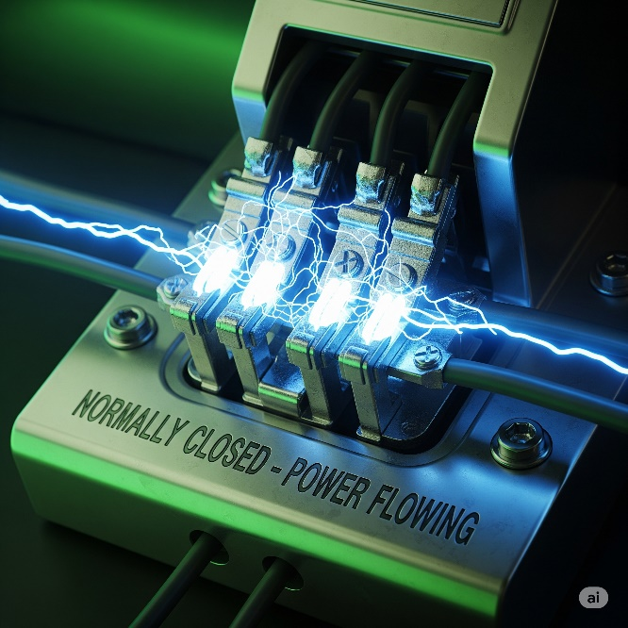

How It Works

* **Normal state:** The contact is CLOSED = Electricity flows through freely
* **When activated:** The contact OPENS = Electricity STOPS flowing
* **Think of it as:** A switch that's normally ON, but turns OFF when triggered

Real World Example: Safety Door on a Microwave

Think about your microwave oven door:

* **Normal state:** Door is closed → Contact is CLOSED → Power flows → Microwave can run
* **When you open the door:** Door opens → Contact OPENS → Power stops → Microwave shuts off immediately

The door switch is "normally" letting power through (closed), but when you open the door, it cuts the power for safety.

Other Common Examples

* **Car seatbelt warning** - Normally quiet when buckled, beeps when unbuckled
* **Fire alarm pull station** - Normally allows system to work, triggers alarm when pulled
* **Emergency stop button** - Normally lets machine run, stops everything when pressed
* **Refrigerator door light** - Normally off when door closed, turns on when door opens

Why Use Normally Closed?

**Safety First!** NC contacts are perfect for safety systems because:

* If a wire breaks or sensor fails → The contact opens → Machine stops (safe)
* You want things to work normally, but stop immediately when something goes wrong

Key Point

The name "Normally Closed" means the contact allows power to flow when nothing is happening to it. When something activates it (danger, problem, or trigger), it opens and cuts the power - making it perfect for safety systems that need to "fail safe."

**⚡** Coils = The Action (Then Do This)

*Coils are outputs. They trigger actions: start motors, turn on lights, activate alarms, etc.*

*Coils are like the "do something" part of your PLC program.*

*When all the conditions on a line are met (all the switches, sensors, etc. are in the right position), the coil gets power and makes something happen in the real world.*

1. Output Coil ( )

This is your basic **"turn something ON"** coil. When the logic is satisfied, it energizes and activates whatever it's connected to.

How It Works

* **Logic satisfied:** All contacts are in the right position → Coil gets power → Device turns ON
* **Logic not satisfied:** One or more contacts block the path → Coil has no power → Device stays OFF

Real World Example: Garage Door Opener

Think of your garage door opener system:

* **Conditions:** Remote button pressed AND safety sensors clear AND power is on
* **Action:** When ALL conditions are met → Output coil energizes → Garage door motor starts → Door opens

Other Examples:

* Turn on conveyor belt motor
* Activate warning light
* Start air conditioning
* Open valve for water flow

2. Negated Output Coil (/)

This is the "turn something OFF when conditions are met" coil. It works opposite to the regular coil.

How It Works

* **Logic satisfied:** Conditions are met → Coil energizes → Connected device turns OFF
* **Logic not satisfied:** Conditions not met → Coil not energized → Connected device stays ON

Real World Example: Smart Thermostat Fan

Think of a cooling fan controlled by temperature:

* **Normal state:** Fan runs to keep things cool
* **Condition:** Temperature drops below 20°C
* **Action:** When temperature IS low → Negated coil energizes → Fan turns OFF (no longer needed)

Other Examples:

* Turn off heater when room gets warm enough.
* Stop alarm when problem is fixed.
* Close valve when tank is full.

3. Latching Coil (L) and Unlatching Coil (U) - Symbols: (L) and (U)

These work like a **"sticky switch"** - once you turn something ON with the Latch coil, it STAYS on even if you let go. The only way to turn it OFF is with the Unlatch coil.

How They Work

* **Latch (L):** Quick pulse of power → Device turns ON and STAYS on forever
* **Unlatch (U):** Quick pulse of power → Device turns OFF and STAYS off forever

Real World Example: Hotel Room Lights

Think of those hotel room card key systems:

* **Insert card:** Latching coil (L) energizes → Room lights turn ON and STAY on
* **Remove card:** Nothing happens → Lights STAY on (that's the latch working)
* **Press main switch:** Unlatching coil (U) energizes → All lights turn OFF and STAY off

**Even Better Example: Emergency Stop System**

Emergency Stop Button Pressed:

* Latching coil (L) energizes → All machines STOP and STAY stopped
* Even if someone accidentally bumps the E-stop button again, machines stay OFF

Reset Button Pressed (by supervisor with key):

* Unlatching coil (U) energizes → System is ready to start again (but doesn't start automatically)

Why This Matters:

Safety! Once an emergency stop happens, you can't accidentally restart dangerous machinery. Someone has to deliberately reset the system with a key.

Other Examples:

* Fire alarm system (latch when smoke detected, unlatch when reset by fire department)
* Security gate (latch open with access card, unlatch closed with timer)
* Process start/stop (latch production line on, unlatch when shift ends)

Key Takeaway

* **Output Coil ( )**: Turn something ON when conditions are right
* **Negated Coil (/)**: Turn something OFF when conditions are right
* **Latch/Unlatch (L)/(U)**: Turn something ON/OFF and make it STAY that way until told otherwise

LOGIC CONCEPTS ILLUSTRATIONS





Boolean equation: AB = Y

Boolean equation: A·**B̅** = Y

See the symbol above B it’s a NOT.

In a truth table, if B is true (1), then B' (or ¬B) is false (0), and vice versa.



Boolean equation: A + B = Y

That’s an OR gate. If either switch is pressed, the Solenoid gets energized.

**LS** typically stands for **"Limit Switch"** a common sensor in industrial applications.

**SOL** stands for **"Solenoid"** which is a device that uses an electromagnet to create a linear or rotational motion. It's a common output device.



Because LS1 and LS2 are in parallel, the current can flow through either one to reach the SOL coil.

* **Scenario 1:** If you actuate LS1 (press the switch) but not LS2, the circuit is complete through LS1, and the SOL is energized.
* **Scenario 2:** If you actuate LS2 but not LS1, the circuit is complete through LS2, and the SOL is energized.
* **Scenario 3:** If you actuate both LS1 and LS2, the circuit is complete through both paths, and the SOL is energized.

The only way for the SOL to *not* be energized is if *neither* LS1 nor LS2 is actuated.

Boolean equation: **(A + B) C = Y**



Boolean Equation: **(A + B) (C + D) = Y**



We're done with note-taking and basic PLC theory. Now it's time to focus on understanding ladder logic through practice, discussions here, and using online PLC simulators for better clarity.

*Let’s first do Timers and Counters which are the final topics that we shall need for this ladder logic drawing… then we shall jump straight into questions beginner to advanced topics….*

**🔧** Mastering PLC Timers, Counters & Internal Memory

**✨** For Future Automation Beasts

I. Intro: Welcome to the Machine

PLCs — they’re not just little boxes with blinking lights. These bad boys are the **real MVPs** of industrial automation. Imagine a PC, but way tougher. We're talking full-time, no-sleep, heat-proof, noise-resistant, punch-a-wall-and-still-run kind of rugged.

*To learn timers, I will take you back to the beginning and come building up.*

What is a PLC?  
It’s a dedicated industrial computer built to **run machines**, handle **real-world inputs and outputs**, and do it all **nonstop, 24/7**, without throwing errors or crashing like your laptop mid-Zoom call.

Why not use a regular PC?  
Because PCs can’t handle the factory life — not the heat, not the voltage spikes, not the dust storms inside a bottling plant. PLCs thrive in the chaos. They were literally **engineered for the madness** of motors, valves, and sensor storms.

Where are they used?  
Everywhere serious automation happens:

* Factory assembly lines 🏭
* Chemical plants 🧪
* Hydroelectric dams 💧⚡
* Food processing lines 🍟
* Basically, anywhere “don’t mess this up” is part of the job description.

**🚀** From Relays to Real-Time Logic

How PLCs Leveled Up

PLCs didn’t start off as the digital ninjas they are today.  
In the beginning? They were just **replacements for clunky relay panels** — good for basic ON/OFF control, a few timers, a few counters. Nothing fancy.

But as industry scaled up, the pressure grew. More machines. More speed. More precision.  
So PLCs had to **evolve** — and they did. Fast.

Now?  
Modern PLCs can:

* Run advanced math operations
* Handle complex logic structures
* Talk to other devices over Ethernet, Modbus, Profibus — you name it
* React to events, not just fixed scans
* Store and manipulate huge sets of internal data

Translation?  
We’re no longer just flipping coils and pushing bits.  
We’re now working with **dynamic, intelligent control systems** that expect you to know how to juggle memory, timing, and communication like a pro.

**📘** Why This Guide Exists

Let’s be honest: learning timers, counters, and memory bits online can be a **hot mess**.  
Some tutorials assume you already know everything. Others teach like it’s still 1995.  
And nobody connects the dots.

So, this guide?  
We’re breaking it down *properly*.  
You’ll learn:

* What each timer and counter really does (not just what the manual says).
* How to actually wire these things in ladder logic.
* Where and **why** to use internal memory bits.
* Real-life examples from automation scenarios.
* Plus, solid resources so you’re not just guessing with YouTube videos.

This is about **leveling up**.  
Not just learning a new instruction — but understanding a whole new mindset:

🔄 One that’s built around timing, memory, logic flow, and real-world constraints.

You ready? Good.  
Let’s build that PLC brain.

**🔁** The Scan Cycle: The Pulse of the PLC

At the core of every PLC’s brain is one relentless rhythm — the **scan cycle**.  
It’s a super-fast loop that never stops, running **thousands of times per second**:

1. 🧠 **Read Inputs** – What’s the world saying right now?
2. 🔍 **Execute Logic** – Based on those inputs, what should we do?
3. ⚡ **Update Outputs** – Send the commands to motors, lights, valves, etc.

This cycle is *everything*.  
It’s how your PLC makes sense of the world — input, decide, act — over and over, like a machine heartbeat.

But here’s the twist that trips up a lot of beginners:

***Outputs don’t change the moment an input changes.***

Nope — they only update **after** the next full scan.  
So if your program relies on microsecond timing or lightning-fast sensors, that tiny delay? It can make or break your whole logic.

That’s why **understanding the scan cycle isn’t optional**.  
It’s essential for:

* Using timers and counters correctly
* Catching fast events (like a sensor that only blinks for a millisecond)
* Designing **reliable**, **predictable**, and **safe** control logic

If your control system is misfiring or feels out of sync?  
🧠 First place to look: **your scan cycle timing.**

**⚡️** II. Ladder Logic: The OG Language of Control

Ladder Logic isn’t just some random PLC programming language — it’s a **deliberate throwback** to the old-school way factories used to automate stuff.

**🧲** Flashback to the Relay Era:

Before 1968, industrial automation meant **relay cabinets** — gigantic walls stuffed with electromagnetic relays wired up in crazy patterns.  
Each relay was basically an electrical switch, and wiring up a control system meant **drawing out a ladder**:

* Two vertical lines = power rails
* Horizontal lines = logic paths (aka “rungs”) with contacts and coils

It worked, but man — it was a nightmare:

* 💸 Expensive
* 🧱 Took up entire rooms
* 🧩 Changing anything meant ripping wires and redoing the layout

**💡** Enter the PLC Revolution

Then came Modicon. Their first PLCs — the **Modicon 084** and the game-changing **Modicon 184** — flipped the entire industry on its head.

Instead of using physical relays, they said:

***“Let’s simulate those relay diagrams in software.”***

And just like that, the first programmable controller was born. Same ladder style. Same logic flow. But now? It’s all done in code.

This was *brilliant*, because:

* Electricians and technicians didn’t need to learn a new language
* They could **read ladder logic just like a wiring diagram**
* No more rewiring — you just changed the program

That’s why Ladder Logic is still the **king** in automation today. It’s familiar. It’s visual. And it gets the job done — especially in environments where clarity, speed, and reliability matter more than code elegance.

**🧠** Relay Logic vs. Ladder Logic: Same Look, Different Game

Here’s where a lot of people trip up — especially electricians making the jump from physical panels to PLCs.

At first glance, **Relay Logic** and **Ladder Logic** look almost identical.  
Same rungs. Same coils. Same contacts. But **under the hood?** Totally different beasts.

**⚙️** Relay Logic: Real Wires, Real Current

Old-school relay logic = **actual electrical current** flowing through **actual wires**, switching **real coils and contacts** in big, noisy panels.

* Contacts are real metal switches.
* Coils are electromagnetic relays.
* Power actually flows left to right on the ladder.

When you press a button, **electricity** physically moves across the rung and energizes something — a motor, a lamp, a siren.

**🖥️** Ladder Logic (PLC): Virtual Wires, Logical Flow

Now flip to PLC ladder logic.  
Same ladder? Yeah. But now:

* The “contacts” are just **memory bits** inside the PLC.
* The “coils” are software instructions.
* And there’s **no real power** flowing — it’s all just 1s and 0s.

When you press a button, the PLC **scans the input**, evaluates the logic, and if the conditions are right? It **sets a memory bit to TRUE**. That bit tells the **output module** to energize the actual hardware — the motor, the lamp, whatever.

So, in the PLC:

"Power flow" = **Logical flow**  
If the rung is TRUE → Output turns ON  
If the rung is FALSE → Output stays OFF

No sparks. Just **binary truth** inside the CPU.

**🔍** What This Means for Troubleshooting

In relay logic, if something breaks, you grab a multimeter and follow the wire.

In PLC logic? You grab your **programming software** and trace the logic:

* Is the input bit changing?
* Is the rung evaluating to TRUE?
* Is the output bit firing?
* Is the output module receiving the command?

It’s not about voltage anymore — it’s about **logic tracing** and **bit behavior**.

This shift to virtual logic is why PLCs are so flexible — but also why new learners need to rewire their brains a bit.

You’re not chasing electrons.  
You’re chasing logic. 🧠⚡

**🧱** Essential Ladder Logic Building Blocks

**💯** Know These, or Don’t Even Start Programming

Before you start writing your first PLC program, you need to **master the basics** — the components that make up every single rung of ladder logic. If ladder logic is a language, these are its alphabet.

**⚡** Rails & Rungs: The Skeleton of Every Ladder

* **Rails** are the **two vertical lines** running down the left and right edges of your ladder diagram.  
  Think of them as the start and end of your logic — like a power source and return line.
* **Rungs** are the **horizontal lines** that stretch between the rails.  
  Each rung = one line of logic. Just like a sentence in programming.

🔀 **Logic flows left to right** — not top to bottom. The PLC reads each rung from left to right, top to bottom, and decides whether it evaluates to TRUE or FALSE.

**🔘** Contacts: Inputs That Control the Flow

Let’s break down the two core types:

1. Normally Open (NO) Contact – --| |--

* Starts out **open** (no logical flow).
* Closes (allows logic to pass) **only when the input is ON** (e.g., a pushbutton is pressed).
* Think: Doorbell. Nothing happens until you press it. 🛎️

If the input bit is TRUE → the contact closes → logic flows through.

2. Normally Closed (NC) Contact – --|/|--

* Starts out **closed** (logic can flow).
* **Opens** (blocks logic) **when the input turns ON**.
* Used in safety systems where failure = shutdown.

🔒 **Example:**  
An emergency stop (E-Stop) is usually wired as NC.

* If it’s working and untouched → logic flows.
* If someone hits the button *or* the wire breaks → the circuit opens → the machine stops.  
  That’s called a **fail-safe design** — *if anything goes wrong, it shuts things down*.

**🧠** Why This Matters

Every control routine starts with understanding:

* What your **inputs** are doing (contacts),
* How the **logic flows** across the rung (left to right),
* And how **your outputs** will respond (which we’ll hit in the next part).

**💡** Output Coils: Lighting Up the Real World

**🔘** OTE — Output Energize Instruction --( )--

This is your **go-to output instruction** in ladder logic. Simple, reliable, and used in almost every basic control task.

**🔌** How It Works

* The OTE coil sits at the **far right** of the rung.
* It waits for **logical power** (i.e., a TRUE condition) to reach it.
* If the rung’s logic evaluates to TRUE → the OTE **energizes** → turns on a real-world output device.

💡 Think:

* Motor starts spinning
* Light turns on
* Solenoid activates
* Buzzer screams at 120dB

**🧠** Important Behavior: No Memory

This part is key:  
The OTE **doesn’t remember anything**. It only stays ON as long as the rung conditions are TRUE.

* Rung TRUE = Output ON
* Rung FALSE = Output OFF  
  No in-between. No delay. No memory.

It’s just like a basic light switch:

Flip the switch ON = light is ON  
Flip it OFF = light is OFF immediately

So, if the input conditions blink ON for just one scan and go back to FALSE, the output also turns OFF — **instantly**.

Use OTEs when you want **simple, responsive, no-state-needed control**.

**🎯** One-Shot Contacts: Mastering Momentary Logic

**🔫** Fire Once, Then Chill.

In ladder logic, sometimes you don’t want an output to stay ON — you just want to **trigger it once** when something changes. That’s what **one-shot** contacts are for. They’re like digital snipers: **One pull. One shot. One scan cycle. Done.**

**⚡** Positive Transition (Rising Edge) — P_TRIG / ONS / --[↑]--

This is your **"On-to-Off" gatekeeper**. It only activates when the input **changes from 0 to 1** — aka a **positive edge** or **rising signal**.

🧠 Example:  
A part passes a photo-eye sensor. The sensor stays ON for a few milliseconds, maybe even several scan cycles.  
You only want to **count the part once**, right?  
If you use a regular contact — it’ll count every scan while the sensor stays ON.  
But with a **one-shot P_TRIG**? Boom — **only counts once**, right when the sensor flips ON.

📌 Real-world use cases:

* Incrementing counters
* Triggering alarms once
* Saving data on an input spike

**🧯** Negative Transition (Falling Edge) — N_TRIG / --[↓]--

Now flip it.  
**N_TRIG** activates **only when the input falls from 1 to 0** — aka **OFF trigger**.

🧠 Example:  
You’ve got a conveyor. You want to **log when a box exits a station**, not when it enters.  
The sensor is ON while the box is present. When the box leaves → sensor turns OFF → N_TRIG fires once. 📌 Perfect for:

* Cleanup logic
* End-of-task triggers
* Logging event completions
* Resetting temporary bits or conditions

**⏱️** One-Shots & Scan Cycles: Timing Is Everything

Here’s the **catch** that most rookies miss:

If the input transitions **faster than your PLC’s scan cycle**, the one-shot might **completely miss it**.

Let’s say your PLC scans every 5ms, but your sensor goes ON and OFF in 2ms.  
Too fast. The PLC never sees the edge → your P_TRIG never fires → missed event. 😵

That’s why:

* You need to know your PLC’s scan time
* For **high-speed inputs**, consider using **dedicated high-speed input modules** or **interrupt routines**

**🧠** Bottom Line:

* One-shots are **event detectors**, not state detectors.
* They let you act on **transitions**, not just steady signals.
* Use them when **"just once"** matters more than **"while true"**.

They’re small, sharp, and surgical. Use with precision. 🩺

**🤖** Boolean Logic in Ladder Diagrams

The Hidden Math Behind the Magic

Even though it looks like wiring, ladder logic is secretly just **Boolean algebra in disguise**. Everything boils down to **TRUE (1)** or **FALSE (0)** — that's it.  
You’re not just placing contacts and coils…  
You’re **building logic gates** with layout alone.

Let’s break down the **three core operations** hiding in your ladder rungs:

**🔗** AND Logic — Contacts in Series

--| |--| |--( )

Place two or more contacts **in a row**, and you’ve got an **AND condition**.

* All contacts must be TRUE (ON)
* If *any one* is FALSE → output = FALSE

🧠 Example:  
A secure lab door that needs:

* ✅ Keycard swipe
* ✅ Password entry
* ✅ Biometric scan

All must pass → THEN door opens.

**🌿** OR Logic — Contacts in Parallel

We already have several images for this.

Put contacts **in parallel**, and boom — it’s **OR logic**.

* Only *one* contact needs to be TRUE
* If *any* path is TRUE → output = TRUE

🧠 Example:  
An alarm system that triggers if:

* 🔥 Fire detected
* 🛑 E-Stop pressed
* 🚪 Door forced open

One sensor goes off → system reacts.

**🔄** NOT Logic — Normally Closed (NC) Contact

--|/|--( )

This is ladder logic’s version of **NOT** — just a single **NC contact** flips the logic:

* If the input is ON → NC contact opens → Output = FALSE
* If the input is OFF → NC contact stays closed → Output = TRUE

🧠 Example:  
A machine that should run **only when the safety gate is closed**.

* Gate open = sensor ON → NC breaks → machine won’t start
* Gate closed = sensor OFF → NC allows logic through

It’s **inverted behavior** — and super useful in safety and interlock circuits.

**🛠️** It’s All About Layout

Here’s the catch:

In ladder logic, **you don’t write AND/OR/NOT — you draw them.**  
Mess up a contact’s placement? You could flip the whole meaning of a rung.

That’s why **meticulous design matters**.  
This isn’t like block-based programming (where you drop an AND gate from a menu).  
Here, the logic is **implied** by how you arrange contacts — and that makes clarity and testing *crucial*.

You’re not just placing instructions —  
You’re crafting **logic flows with spatial awareness**.

That's why ladder logic is powerful, but **you gotta think like both an electrician and a programmer**.

**🔒** The Latching (Seal-In) Circuit

Holding Power Without Holding the Button

This is one of the **most common control patterns** you’ll ever use in ladder logic — the **seal-in**, also known as a **latching circuit** or **holding contact**.

What does it do?  
It **keeps an output ON** even after the button that started it has been released.

**🧠** Why is this useful?

Imagine pressing a "Start" button and having to **hold it forever** just to keep a machine running.  
Ridiculous, right? That's why we build a **logic memory loop** that says:

***"If I started, I’ll stay ON — until told to stop."***

**🔧** Classic Latching Circuit Breakdown

**Components:**

* 🟢 **Start button** → Normally Open (NO) contact
* 🔴 **Stop button** → Normally Closed (NC) contact
* ⚙️ **Output coil** (motor, light, etc.) → OTE
* 🧠 **Seal-in contact** → NO contact tied to the output

**How It Works:**

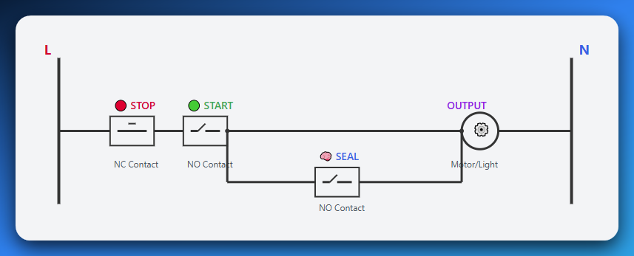

1. **Start pressed**:
   * Logic flows through **NC Stop** and **NO Start** → energizes output coil
2. **Output turns ON**:
   * Its associated contact (seal-in) **closes** — now there’s a **new path** for logic
3. **Start released**:
   * Doesn’t matter — seal-in is doing the job now. Output stays ON.
4. **Stop pressed**:
   * NC Stop opens → logic is cut off → output de-energizes → seal-in opens → resets the loop

**🧰** Real-World Use Case: Motor Start/Stop

* Press "Start" → Motor turns ON
* Release "Start" → Motor keeps running
* Press "Stop" → Motor shuts off

This behavior is **crucial** in:

* Motor control
* Conveyor systems
* Pumps
* Anything where **continuous operation** is needed after a momentary trigger

**🧠** Why It Matters

Seal-in logic introduces the idea of **memory** — holding a state across time.  
You’re not using a retentive bit yet, but it’s the **first step** to understanding:

* Retentive timers.
* Latching bits.
* Preserving state through logic loops.

And it’s also critical for **safety** — a machine shouldn't stop just because a button was accidentally let go. It should stop only when the operator **deliberately presses STOP**.

**💡** Key Concept: Self-Holding

The seal-in contact creates a **parallel path** around the start button. Once energized, the output "holds itself ON" through this parallel path, even when the start button is released. Only the stop button can break the circuit and reset the system.

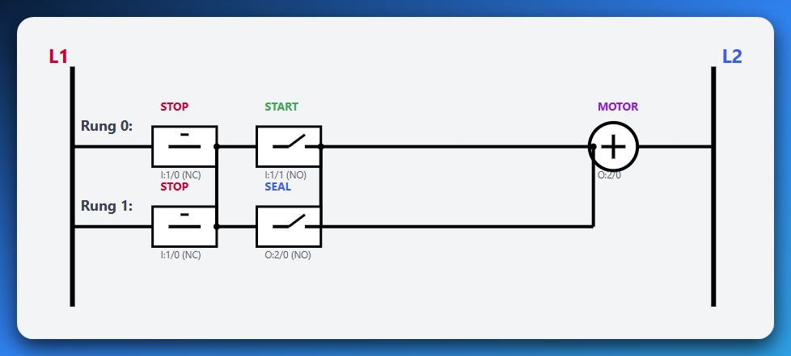

**🔍** What You See Here:

* **Two Rails:** L1 (left) and L2 (right) - like + and - on a battery
* **Two Rungs:** Two parallel paths for electricity to flow
* **Rung 0:** STOP → START → MOTOR (main control)
* **Rung 1:** STOP → SEAL → MOTOR (holds motor ON)
* **Connection Dots:** Show where wires connect together

**⚡** How It Works:

1. **Press START:** Electricity flows through STOP→START→MOTOR
2. **Motor Turns ON:** This closes the SEAL contact
3. **Release START:** Electricity now flows through STOP→SEAL→MOTOR
4. **Press STOP:** Both paths are broken, motor turns OFF

**💡** The Magic of the Seal-In:

Look at the **SEAL contact (O:2/0)** - it's controlled by the same motor output! When the motor turns ON, it automatically closes this contact, creating a second path to keep itself running.

This is called **"self-holding"** or **"latching"** - the circuit holds itself ON!

**🏷️** Address Labels Explained:

**I:1/0** = Input 1, Bit 0 (Stop button)

**I:1/1** = Input 1, Bit 1 (Start button)

**O:2/0** = Output 2, Bit 0 (Motor)

**🧠** OTL & OTU: Retentive Control Made Easy

**🔒** When You Want Full Manual Control Over ON/OFF States

Sometimes the classic seal-in circuit isn’t enough — you need **precise control** over what stays ON or OFF, even if the logic around it changes.

That’s where the **OTL (Output Latch)** and **OTU (Output Unlatch)** instructions come in.

These are **retentive instructions** — meaning once they set or clear an output, it stays that way **until you explicitly change it**.

Let’s break it down:

💥 OTE — Output Energize

The default. The basic.

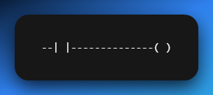

* 🧠 **Memory?** None. Volatile.
* ON if rung logic is TRUE.
* OFF the moment logic goes FALSE.
* Great for: Lights, fans, motors — anything that should turn off instantly if the input fails.

💥OTL — Output Latch

Sets the output **ON**, and keeps it ON.

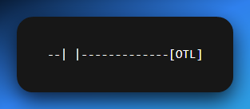

* 🧠 **Memory?** YES. Retentive.
* ON when rung goes TRUE (even for just **one scan**)
* **Stays ON** until a matching OTU resets it
* Useful for:
  + 🔔 Emergency alarms (require manual reset)
  + 🚩 Status flags (“process complete”)
  + 🛑 Holding a machine in a STOPPED state after fault

💥OTU — Output Unlatch

Turns the same output **OFF**, and keeps it OFF.

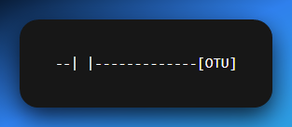

* 🧠 Also **retentive**
* OFF when this rung becomes TRUE (even once)
* **Stays OFF** until something else (like an OTL) turns it back on
* Used for:
  + 🔁 Resetting alarms
  + ✅ Clearing flags or error states
  + 🧼 Cleanup logic after a batch run

🧩 Example Use Case: Fault Alarm Logic

*If fault → OTL → Alarm ON*

*If reset button → OTU → Alarm OFF*

This lets you keep the alarm blaring *even if the fault clears*.  
The operator must press RESET — ensuring they **saw and acknowledged** the error.

**⚠️** Pro Tips:

* OTL/OTU pairs **must use the same address/tag**
* Don’t mix OTL with OTE on the same output — it causes unpredictable behavior
* Retentive = **survives logic changes**, but *may not* survive power loss unless stored properly

Use OTL/OTU when you need **intentional, human-triggered state changes**, not just auto-on/off behavior. It’s all about **control and safety**.

**🧠** Memory vs. Moment: Why This Difference Matters

Here’s the real takeaway from the table:

* **OTE** = **reactive**
  + It mirrors the rung logic — ON when true, OFF when false.
  + Like a light switch: flip it, and it instantly obeys.
* **OTL / OTU** = **retentive**
  + They don’t care what the logic *currently* says.
  + They remember the last command — ON or OFF — and **hold it** until told otherwise.

**🎯** Why That’s Huge

This difference isn’t just technical — it’s **philosophical**.  
You’re deciding *how much control the PLC keeps vs. how much you, the programmer, take over*.

🔐 Use retentive logic (OTL/OTU) when:

* You want a machine to **remember a fault** until the operator resets it
* You’re building a **multi-step sequence** (like filling → mixing → draining)
* You’re creating **interlocks** for safety that must be manually cleared

⚡ Use volatile logic (OTE) when:

* You want instant response to input changes
* The output should reflect **real-time** status (like lights or fans)
* Memory would actually cause confusion or danger

**🧱** It's the Foundation of Sequential Control

Retentive logic is the backbone of:

* Step-by-step automation
* Process hold states
* Fault detection and reset
* Operator-controlled resets and acknowledgements

If you want your PLC to **act like a brain**, not just a switchboard —

You’ve got to master the art of memory-based output logic.

**🧠** Internal Memory Bits — Your PLC’s Hidden Superpower

**📦** M-Bits / Internal Relays / Flags — Whatever You Call Them, They’re Game-Changers

Okay, so you already know that X is for inputs and Y is for outputs in Mitsubishi PLCs.

But what if you want to store a result, remember a condition, or build logic that has **nothing to do with physical wiring**?

That’s where **internal memory bits** come in — the M range.

**⚙️** What Are M-Bits?

M-bits (M0, M1, M100...) are **virtual switches** inside the PLC’s brain.

* They’re **Boolean variables**: either ON (1) or OFF (0).
* You **don’t wire them** to anything.
* They live entirely **in software.**

💡 You can think of them like this:

If physical inputs/outputs are the muscles, M-bits are the neurons — internal signals making decisions behind the scenes.

**🧩** How Are They Used?

Let’s say you have a huge condition like:

* Input A is ON.
* AND Input B is OFF.
* AND the motor isn’t already running.
* AND a timer has expired.
* AND another condition from 5 rungs back is true.

😵 Trying to cram that into one rung? Good luck debugging that in an exam or real system.

Instead:

1. **Break it into smaller parts.**
2. Store partial results in M bits (M100, M101, etc.)
3. Use those M bits as contacts in other rungs.

Now your logic is **clean**, **modular**, and **easy to follow**.

**🔁** Example in Mitsubishi:

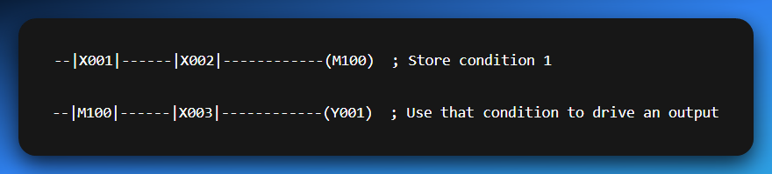

This lets you “build logic in layers” — just like you do with if statements or functions in Python or C.

**🧼** Why Use M-Bits?

* ✅ To **store results** from previous logic.
* ✅ To **simplify complex rungs.**
* ✅ To **add memory** to your logic without using OTL/OTU.
* ✅ To create **modular, reusable chunks** of control.
* ✅ To make your program **easy to debug** and maintain.

It’s the difference between spaghetti logic and **engineered control flow**.

**🧠** Pro Tip for Mitsubishi Folks:

* Inputs → X (e.g., X001)
* Outputs → Y (e.g., Y001)
* Internal relays → M (e.g., M100)
* Timers/Counters → T, C
* Constants/Data → D, K, etc.

Think of M-bits as your **scratchpad memory** — they hold your thoughts while you solve the puzzle. Once you master them, your ladder diagrams will go from basic to pro-level real quick.

This next chunk right here is **the juice**.

You’re learning how to **build real-world PLC behavior**, not just light bulbs and motors — but structured, modular, and *safe* systems.

M-bits don’t just store logic; they **organize and control entire machine states**.

Let’s refactor this into something 🔥sharp, real-world, and easy to visualize.

**⚙️** Practical Power: How to Use M-Bits Like a Pro

Flags, Intermediate Logic, and Master Control — The Real Deal

Internal memory (M) bits are not just for breaking long rungs — they’re your **logic control tools**, the way you make your PLC **think clearly** and **act smartly**.

Let’s walk through **three powerful ways** to use them:

**🏁** 1. Flags — Status Indicators

**Flags** are M-bits that act like labels or checkpoints for your program.

📍 Examples:

* **M100 → Machine_Ready**
* **M101 → Fault_Active**
* **M102 → Sensor_Triggered**

Once a flag is ON, **anywhere else** in your program can check it like:

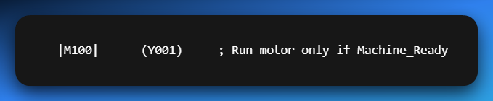

Think of it like this:

***"Hey PLC, remember this condition happened? Cool — now let’s use that info later."***

**🧮** 2. Intermediate Logic — Break It Down to Build It Right

Complex logic can get ugly fast.  
Instead of this mess:

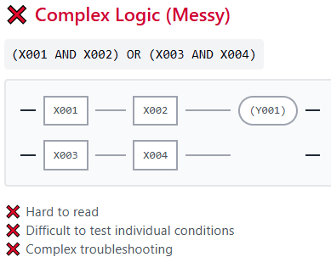

Split it up like a smart coder:

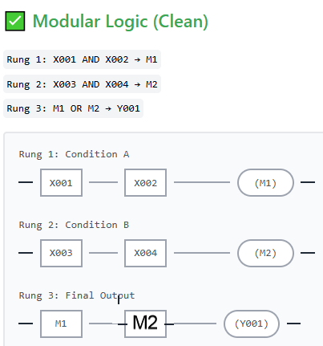

✅ Easier to read  
✅ Easier to test  
✅ Easier to debug during an exam or live run

It’s **ladder logic modularity** — just like clean code in Python or C.

**🧷** 3. Master Control Relay — The Big Switch

This is **crucial for safety and system structure**.

Let’s say you’ve got a whole section of outputs — motors, valves, alarms — and you want to **disable them all instantly** when something goes wrong or the operator hits STOP.

🔧 Create a master relay like M200 (e.g., System_ON)

Then put that M200 contact in every rung:

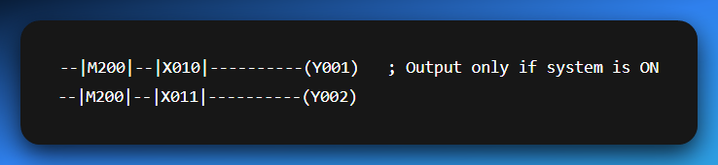

Control M200 with your start/stop logic:

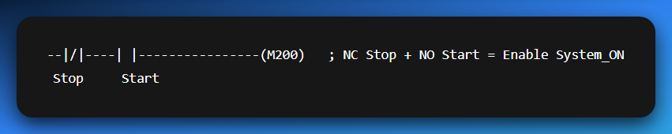

Now pressing STOP **cuts off everything**, like a master switch.  
✅ Safe.  
✅ Predictable.  
✅ Easier to read  
✅ Easier to test (M1, M2 individually).  
✅ Easier to debug during exams/live runs.

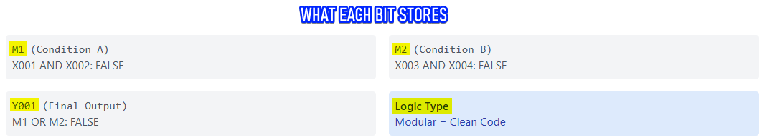

Internal M-Bits: Structured Control



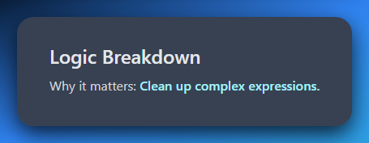

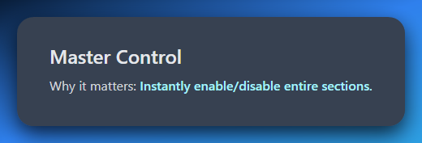

Internal memory is what takes your program from "works" to **works well** — clean, scalable, and *factory-ready*.

➡️ *Does your PLC remember... or forget everything the moment power dies?*

Let’s break this down so it **sticks like glue**, and you **never misuse a memory bit** again.

**🧠** Retentive vs Non-Retentive M-Bits

What Happens When the Power Goes Out?

Not all M-bits are created equal. Some forget like goldfish 🐠... others remember like elephants 🐘.

And you, the programmer, decide which behavior you want.

**🧼** 1. Non-Retentive M-Bits — The Forgetful Kind

Most M-bits (by default) are **volatile** — meaning:

* If the PLC **loses power** or is switched to **PROGRAM mode**
* These bits **reset to OFF (0)**
* Everything they “remembered” is gone

✅ Good for:

* Temporary flags
* Intermediate logic
* States that should *always reset* on power-up

📍Example:

*M100:* ***"Start_Pressed"*** *→ Only relevant during runtime.*

You *want* this to reset so no ghost input causes logic to fire when power comes back.

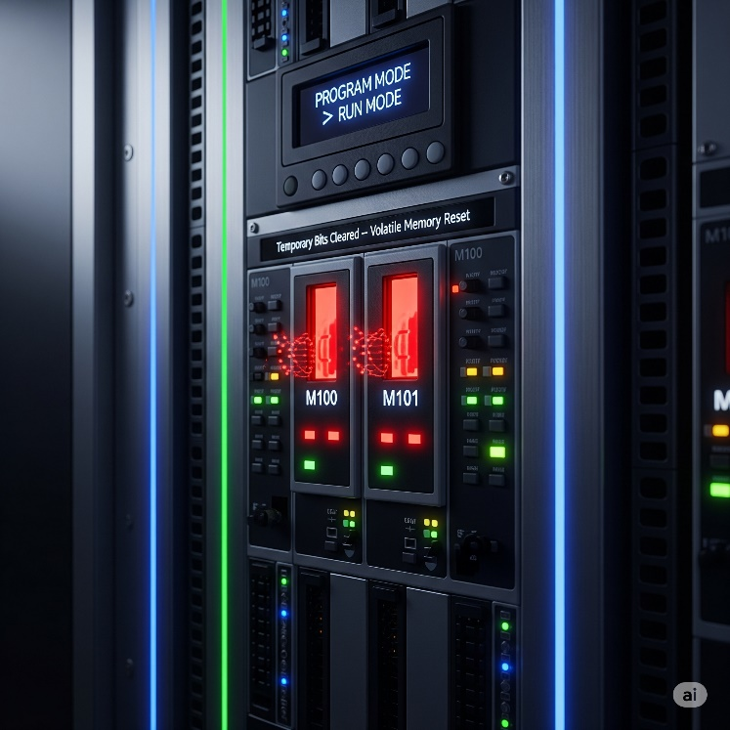

**🧲** 2. Retentive M-Bits — The Memory Keepers

Some M-bits are **retentive**. These are backed by internal battery power or stored in a persistent way inside the PLC.

* They **remember their state** even if:
  + Power goes out.
  + PLC is restarted.
  + Scan cycle is interrupted.

✅ Use them when you **must preserve state**. Example:

*M200:* ***“System_Stopped_Due_to_Fault”*** *→ You don’t want this cleared, until operator resets it.*

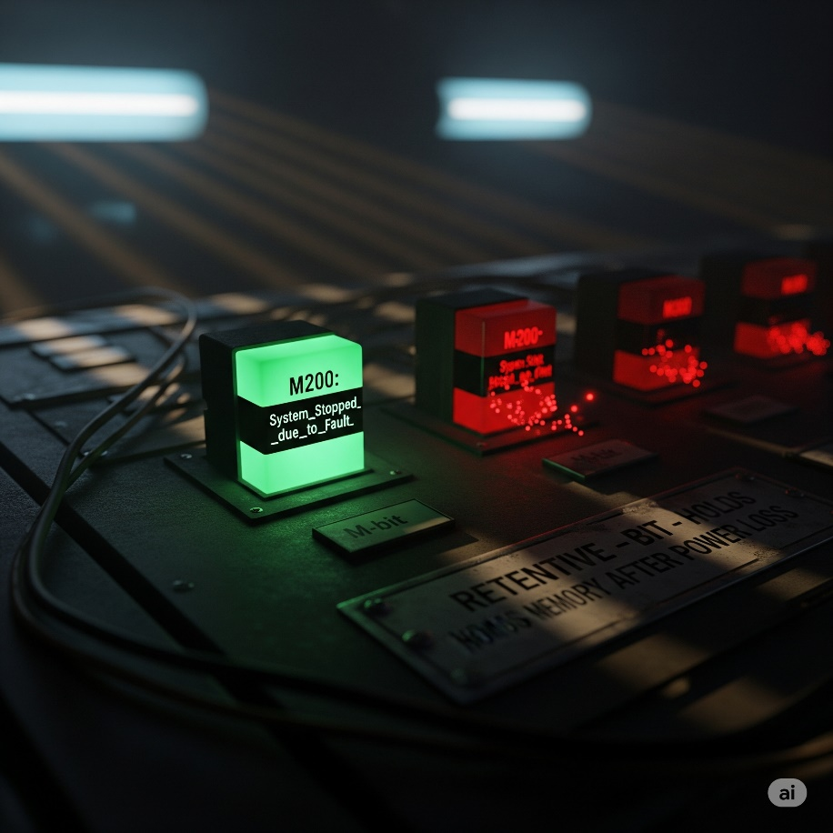

**⚠️** Why It Matters

Scenario A:

A batch mixing system is halfway through step 3 when the power dies.

* ❌ If all your M-bits were non-retentive → the PLC boots up and has no clue where it left off
* ✅ If you saved step progress in retentive bits → the system resumes like nothing happened

Scenario B:

A fault occurred. You want the operator to see it after reboot.

* ❌ Non-retentive = fault flag disappears
* ✅ Retentive = fault flag still ON → Operator sees and clears it

**🔐** Design Rule of Thumb

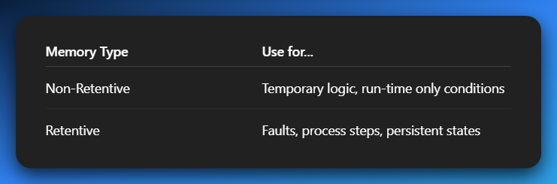

Mixing them up = recipe for **bad logic** or **unsafe resumes**.

**📌** In Mitsubishi PLCs:

You’ll often configure **ranges** of M-bits as retentive in the **PLC parameters**.

For example:

* **M0–M499 → Non-retentive.**
* **M500–M999 → Retentive.**

Check your software (like GX Works) to define or view this split.

**🧠** Final Word:

When power comes back, your program should either:

* **Restart cleanly** like a fresh boot.
* Or **pick up where it left off**, like nothing happened.

Your **choice of retentive vs non-retentive bits** is what makes that happen.

**🧩** Real-World Uses of M-Bits

Practical Logic with Flags, Intermediates, and Master Control

M-bits aren't just "extra space" — they're your secret tools for organizing, controlling, and simplifying your entire program.

Here’s **how pros actually use them** in everyday logic:

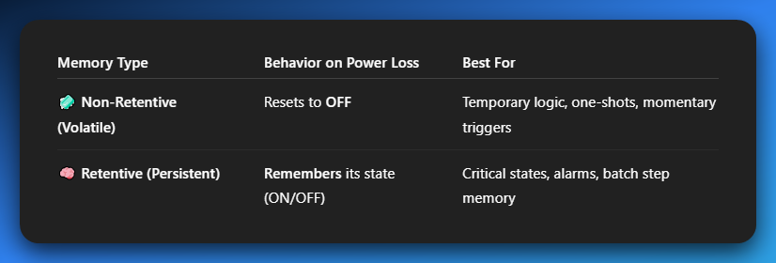

**✅** 1. Flags / Status Indicators

Flags = M-bits that mark something as ON/OFF (TRUE/FALSE) in your program.

Think of them as **checkpoints**:

* **M100 → Machine_Ready**
* **M101 → Fault_Active**
* **M102 → Sensor_Clear**

Instead of checking multiple raw inputs again and again, just check the flag:

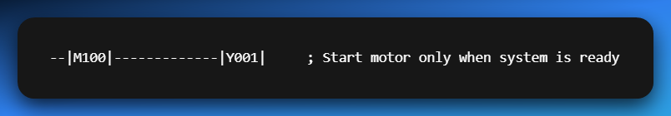

💡 **Flags simplify conditions and make logic readable**.

**🧠** 2. Intermediate Logic Storage

Ever seen an ugly rung like this?

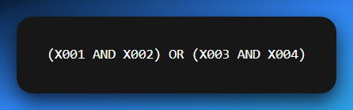

Messy and hard to debug, right?

💡 Solution: Break it up using M-bits:

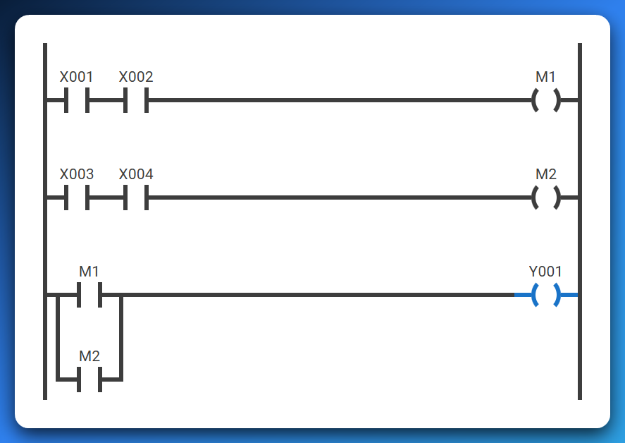

✅ Cleaner  
✅ Easier to troubleshoot  
✅ You’ll thank yourself during exams

**🚨** 3. Master Control Bit (MCB)

Use an M-bit like a **main switch** to enable or disable entire sections of the program.

**Example: M200 → System_ON (controlled by start/stop buttons)**

Then use it like this:

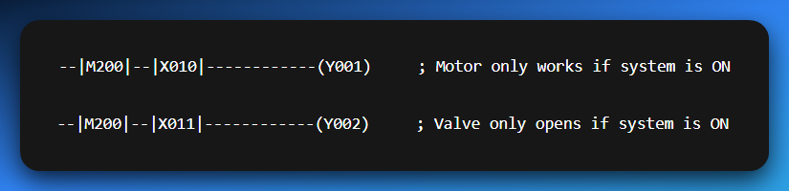

If the STOP button breaks the latch and M200 turns OFF, **everything shuts down** — instantly.

✅ Safety-compliant.  
✅ Easy to organize.  
✅ Clean sequencing control.

**🔑** Summary Table 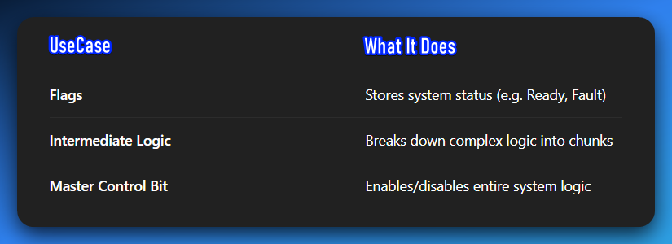

M-bits = **modular design, safety control, and clean programming.**  
Every decent PLC project uses these like glue holding everything together.

**⏱️** PLC TIMERS DEMYSTIFIED: TIME-BASED CONTROL MADE SIMPLE

Chapter IV: Mastering Timing Logic

We’re now in the deep waters, let’s go! 💥  
In the real world, **not everything happens instantly**.  
Need a delay before a conveyor starts?  
Want a light to stay on for 10 seconds?  
Or pause between steps in a process?

That’s what **timers** are for.  
They let you go **beyond simple ON/OFF** logic — adding time-based control to your ladder program.

**🚀** What Are Timers in PLC?

Timers are **built-in instructions** that count time when conditions are met.  
They trigger events **after** a specified time delay.

**Examples:**

* Keep a fan running for 5s after machine stops
* Flash a light every 0.5s
* Add a delay between solenoid activations

**🧩** All PLC Timers Have These Core Parts

**Let’s break this down in plain English: PLC Timer parameters**

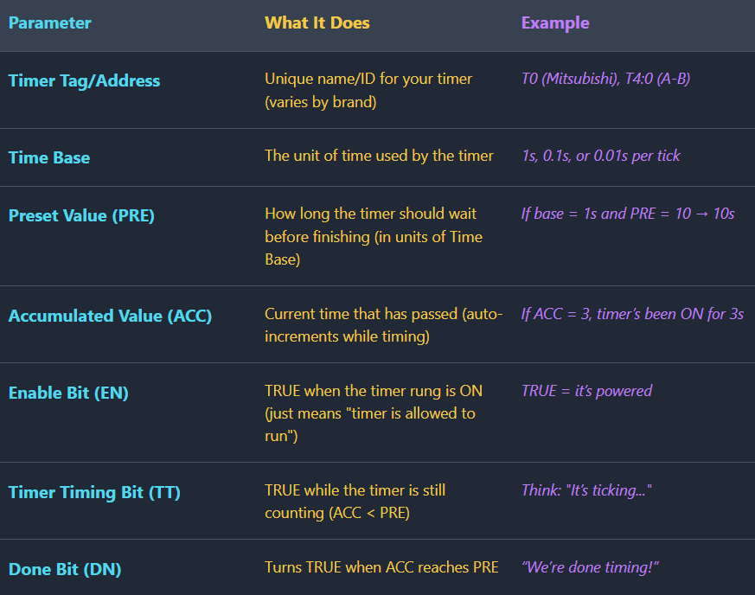

PLC Timer Parameters: Quick Notes

Timer Tag/Address

This is the unique name or ID that identifies a specific timer in your program.

Time Base

This defines the unit of time, like seconds or milliseconds, for each "tick" of the timer.

Preset Value (PRE)

This is the total amount of time, in Time Base units, that the timer must count up to.

Accumulated Value (ACC)

This tracks the current time that has passed since the timer started running.

Enable Bit (EN)

This bit is TRUE when the timer’s circuit is powered, allowing it to start counting.

Timer Timing Bit (TT)

This bit is TRUE only while the timer is actively counting, before it reaches its Preset Value.

Done Bit (DN)

This bit turns TRUE as soon as the timer’s Accumulated Value is equal to or greater than the Preset Value.

**🔁** Real-Life Analogy

Let’s say you're boiling an egg for 5 minutes:

* **EN** = you turned on the stove.
* **TT** = it's still boiling.
* **DN** = timer rings after 5 mins (egg done!).
* **ACC** = shows how long the egg has been boiling.
* **PRE** = your 5-minute goal.
* **Time Base** = counting in seconds or tenths.

**⚙️** Use Case Examples

Light turns off 10s after button press

Use ON-delay timer with PRE = 10

The ON-delay timer starts counting when the button is pressed, and after 10 seconds, it activates the output to turn the light off.

Motor starts 3s after system power-up

Delay with PRE = 3 before output

A timer is initiated on system power-up and counts for 3 seconds before activating the output that starts the motor.

Flash alarm light every second

Toggle logic + timer reset loop

A timer with a Preset of 1 second is used in a loop that resets itself, and its timing bit is used to toggle the alarm light on and off.

***Timers*** *control over when things happen, not just what happens. They’re the heartbeat of delays, sequences, and safety timeouts.*

**⏳** On-Delay Timer (TON): Wait Before You Act

**Think:** *"I’ll wait for X seconds, then I’ll turn ON"*

**🔍** What Does TON Do?

An **On-Delay Timer** delays its output from turning ON until a preset time passes — *but only if the input stays ON the whole time*.

So, it’s basically saying:

*“If you’re serious about this signal, hold it steady. No quick taps.”*

**⚙️** TON Timer Behavior Breakdown

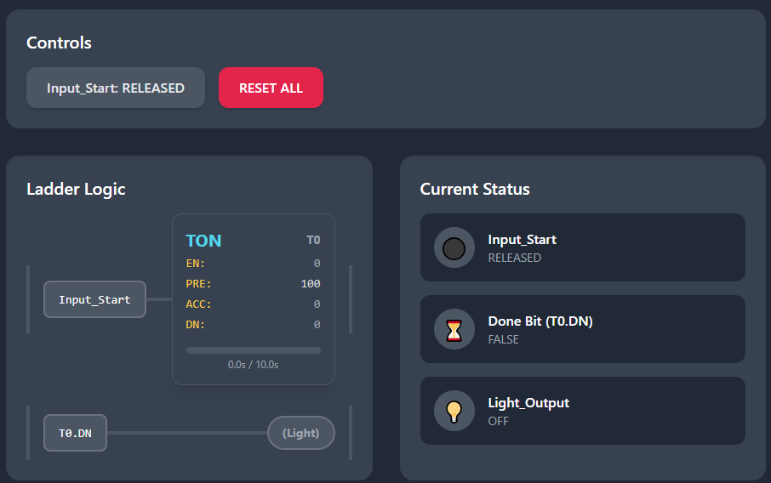

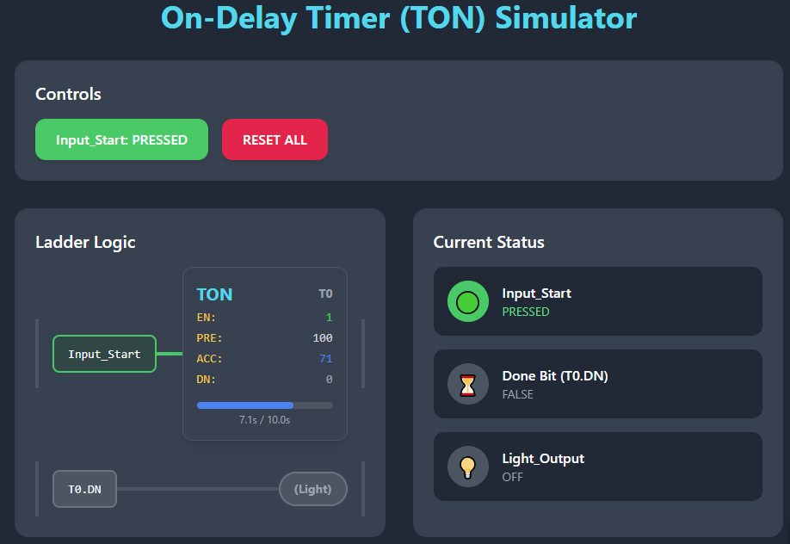

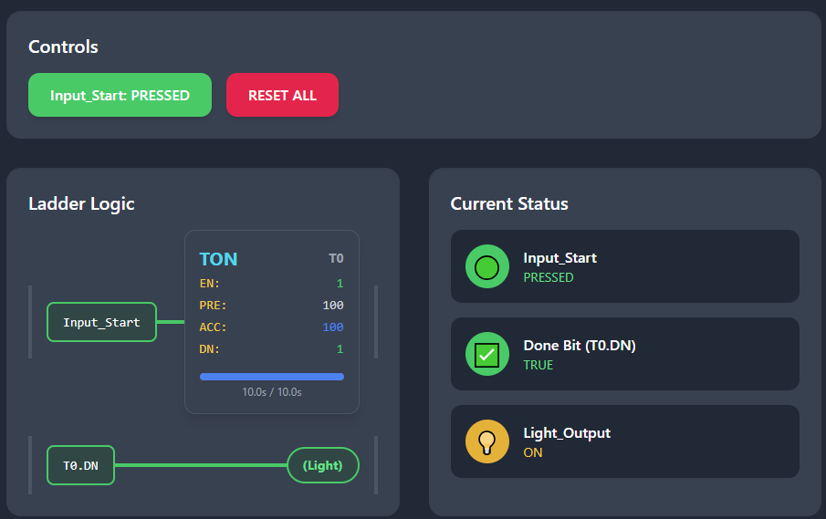

When the input rung turns **TRUE**, the timer starts counting up, and the accumulated value (ACC) increases.

If the input remains **TRUE** until the accumulated value (ACC) equals the preset value (PRE), the **Done (DN)** bit turns **TRUE**, activating the output.

If the input goes **FALSE** before the accumulated value (ACC) reaches the preset (PRE), the ACC resets to **0** and the DN bit remains **FALSE**.

If the input goes **FALSE** after the DN bit is **TRUE**, the ACC resets and the DN bit turns **FALSE** again.

🧠 In short:

* **It waits** to turn ON.
* **It resets instantly** if input is lost.
* **No memory** — doesn’t hold state once input dies.

**🛠** Real-World Uses for TON:

* Safety delays (e.g., wait 5s before re-starting)
* Signal debouncing (ignore fast button taps)
* Sequential process delays (e.g., wait before opening next valve)

**🔁** TON = Patience Timer

* It **doesn’t rush** into action.
* It needs **consistent input.**
* It **resets instantly** if trust is broken.

**🧯** Off-Delay Timer (TOF): Stay ON a Bit Longer

Think: *“I’ll stay ON for X seconds after input goes OFF.”*

**⚙️** TOF Behavior Breakdown

Normal state.

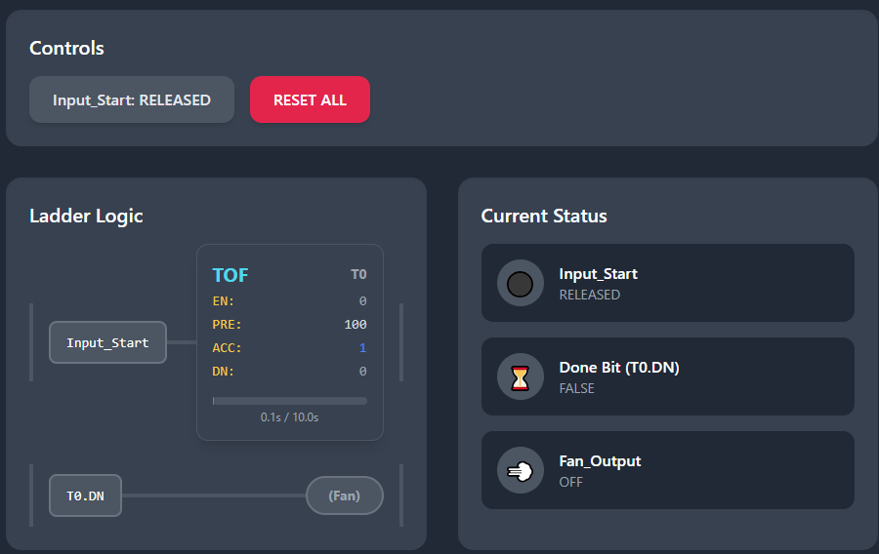

Input pressed:

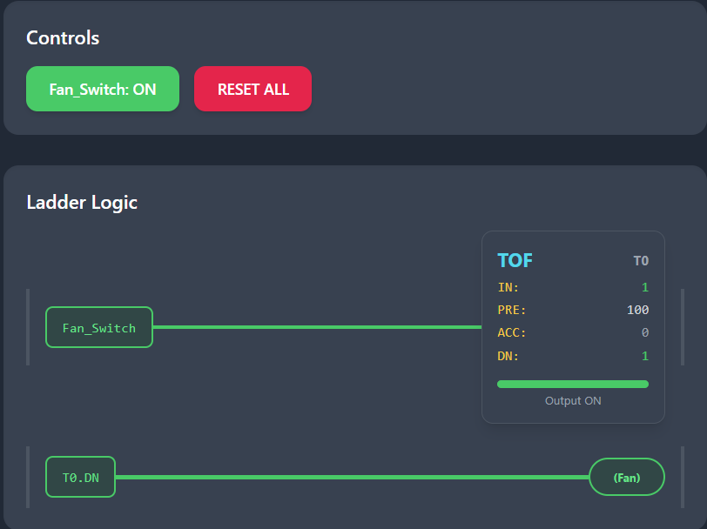

Input released and becomes False counts, then goes back to state 1:

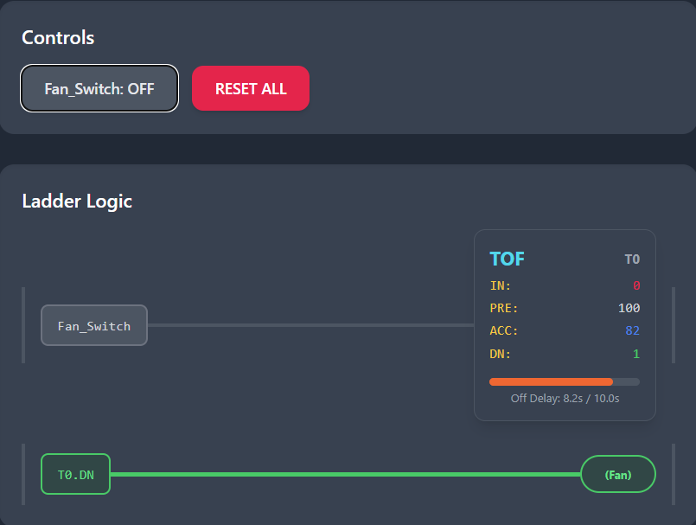

When the input rung turns **TRUE**, the **DN (Done)** bit turns **TRUE** immediately.

While the input remains **TRUE**, the timer stays idle and the accumulated value (**ACC**) remains at **0**.

When the input turns **FALSE**, the timer begins counting and the **ACC** value starts increasing.

When the **ACC** reaches the preset value (**PRE**), the **DN** bit turns **FALSE**, which causes the output to turn **OFF**.

If the input turns **TRUE** again during the countdown, the **ACC** resets to **0**, the **DN** bit stays **TRUE**, and the delay restarts.

🧠 In short:

* **Output turns ON immediately.**
* **Stays ON** even after input is OFF — but only for the preset time.
* **Cancels countdown** if input turns ON again.

**🛠** Real-World Uses for TOF:

* Cooling fans (e.g., after welding, drying, or heating)
* Ventilation after motor stops
* Delay-off buzzers or alarms
* Lights that stay ON for a few seconds after leaving a room

**💥** TOF = “Let me finish my job before I shut off”

* It’s **immediate on**, **delayed off**
* Adds **grace period** before shutting down
* Helps prevent **premature shutoffs**

*You’ve now mastered both ends of the timer spectrum:*

* **TON** = waits to turn ON
* **TOF** = waits to turn OFF

⏳ Retentive Timer (RTO): The Timer That Remembers

While a TON resets if its input drops, RTO is like:

*“Nah, I’ll keep counting... even if you try to stop me.”*

🔁 How RTO Works

The original state:

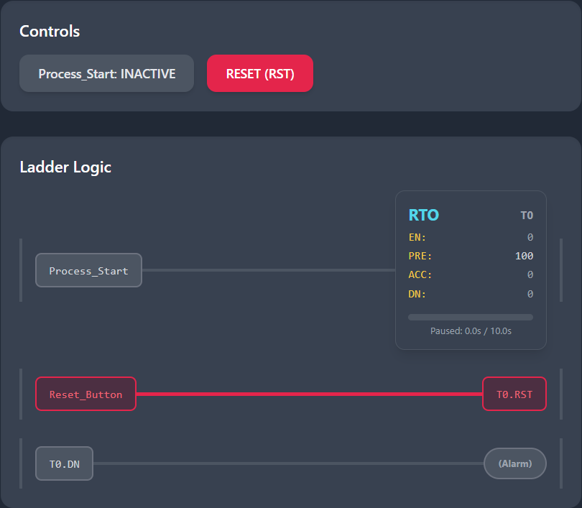

When the rung turns **TRUE**, the Retentive Timer On (RTO) starts counting, and the accumulated value (ACC) increases.

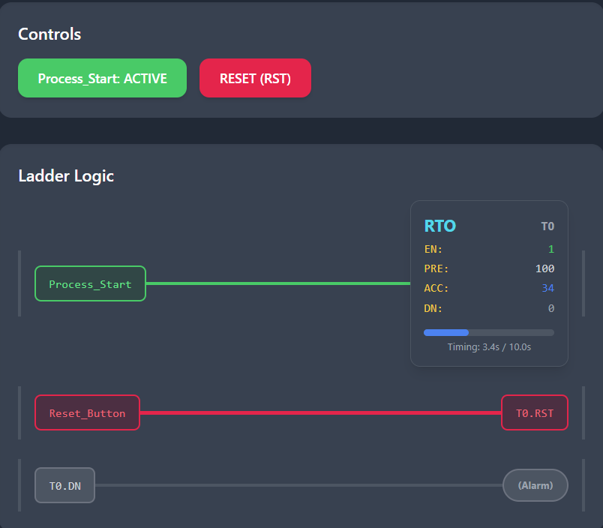

If the rung turns **FALSE**, the timer holds its current accumulated value and does **not** reset.

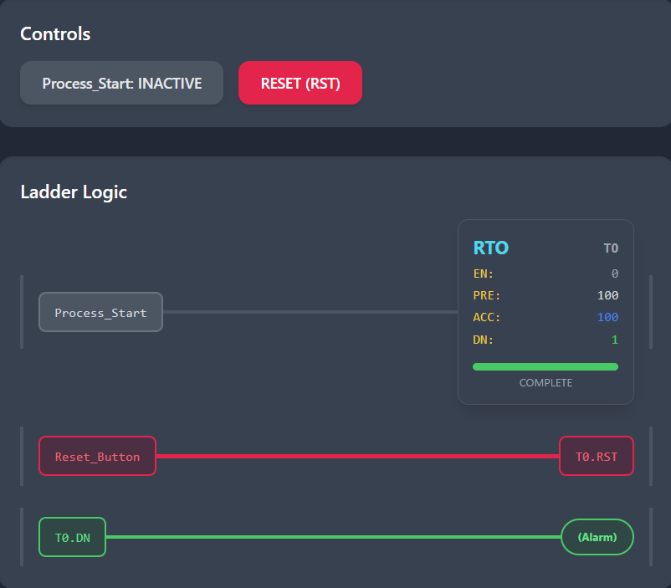

When the rung turns **TRUE** again, the RTO resumes counting from where it left off.

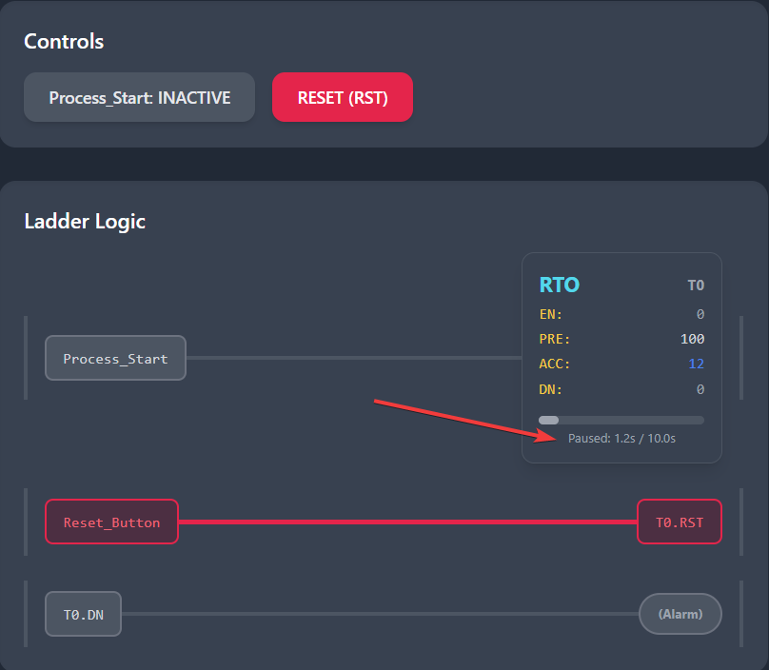

Resumes:

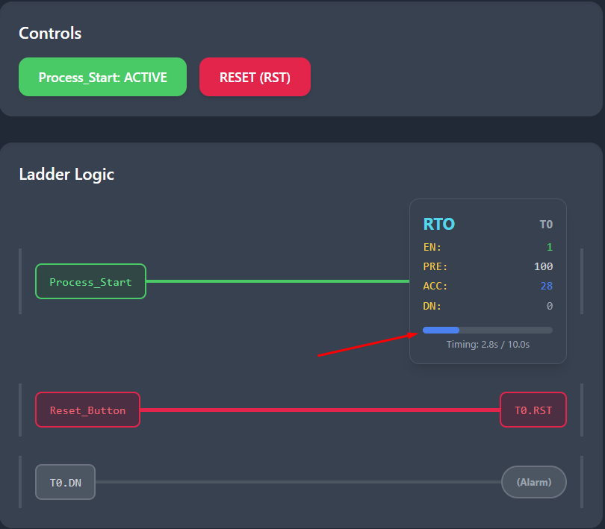

Once the accumulated value (ACC) is **greater than or equal to** the preset value (PRE), the **Done (DN)** bit becomes **TRUE** and remains TRUE.

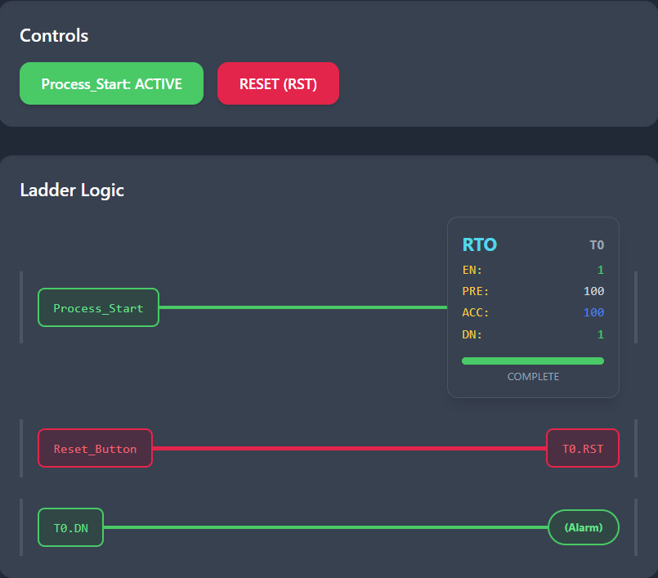

**🧠** Real-Life Uses of RTO:

* **Tracking machine runtime** (maintenance alerts)
* **Total cycle accumulation.**
* **“Resume where you left off” processes.**
* **Long processes that span across multiple sessions.**

**🔄** Summary:

* **RTO ≠ forgetful**
* Always pair it with a **RES**
* Think of it as a “**persistent TON**”
* If you don’t clear it, it’ll mess with your logic on the next run

**⏱️** 1. TON (On-Delay Timer)

**Analogy:** *A microwave oven with a delay before it starts heating.*  
When you press “Start,” the microwave doesn’t begin heating immediately. Instead, it waits for a few seconds (like a delay) before turning on. If you cancel before the delay ends, it never starts.  
→ The **TON** waits for the preset time **before** turning the output **ON** after the input turns **TRUE**.

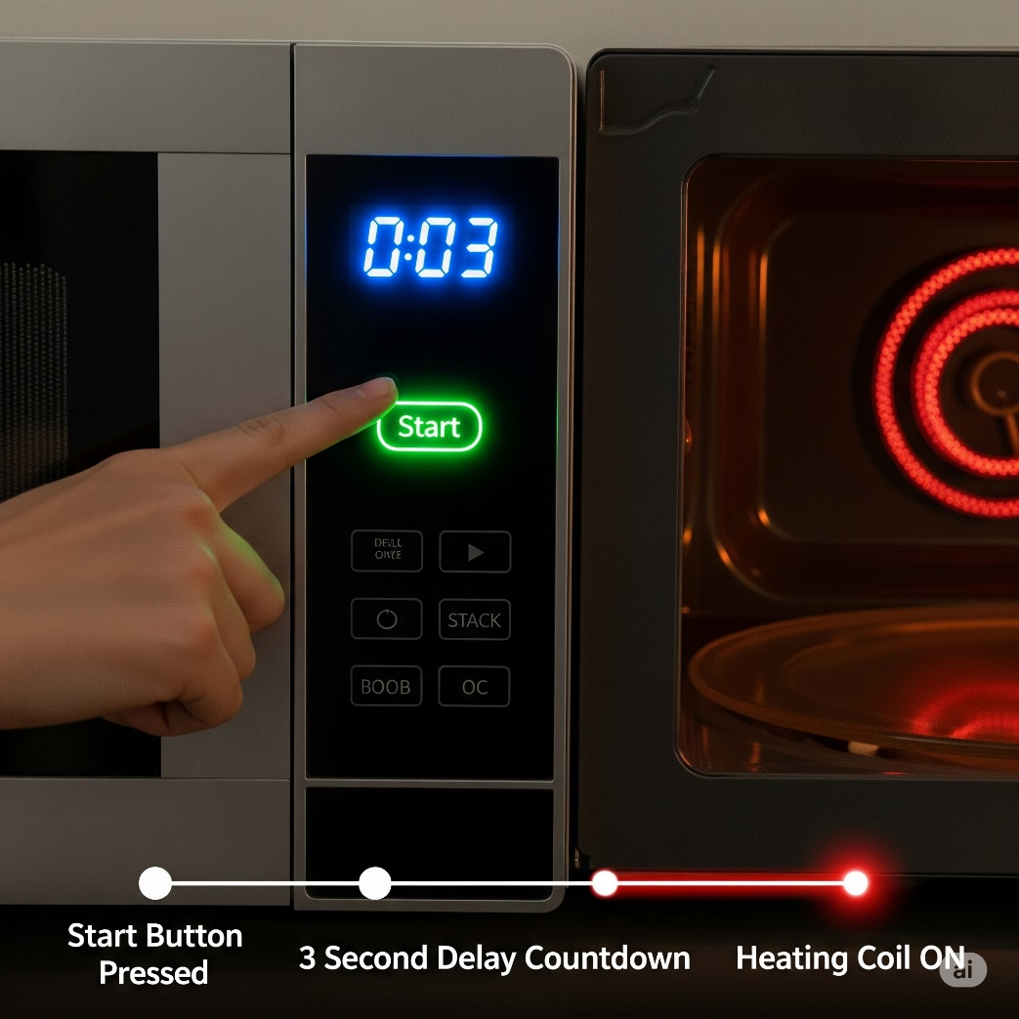

**❄️** 2. TOF (Off-Delay Timer)

**Analogy:** *A cooling fan for a hot engine.*  
The fan turns on immediately when the engine (input) starts. When the engine turns off, the fan continues to run for a preset time to cool things down. Only after this delay does the fan turn off.  
→ The **TOF** keeps the output **ON** for a preset time **after** the input turns **FALSE**.

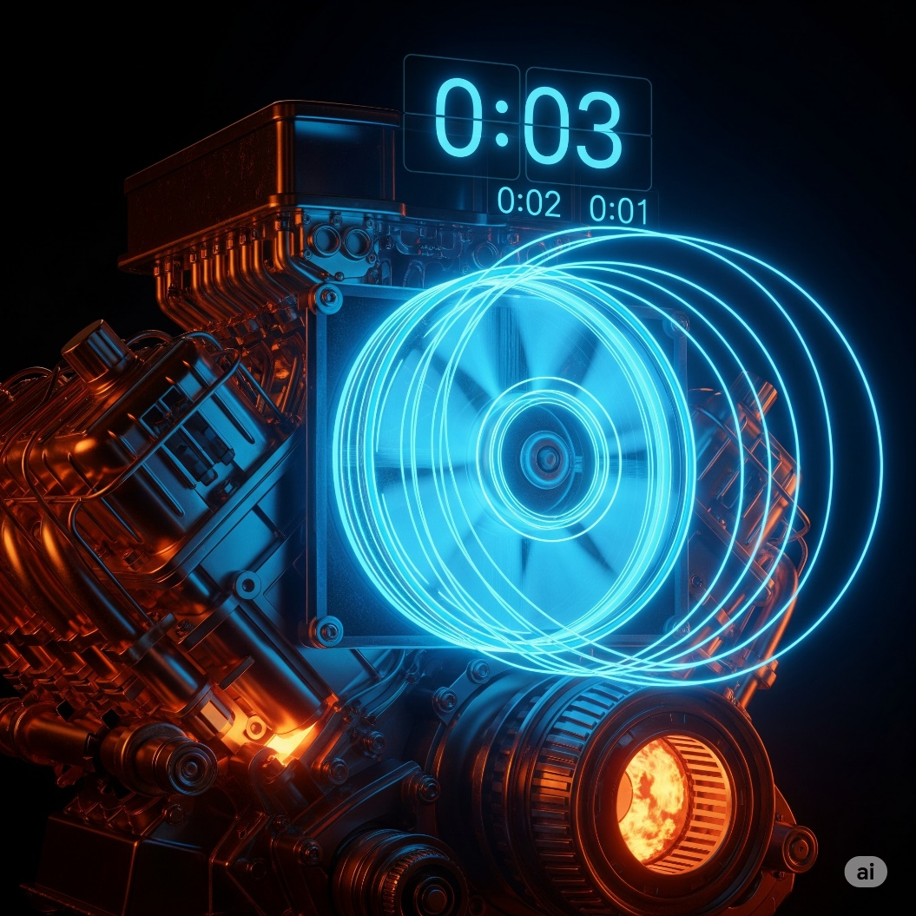

**🔁** 3. RTO (Retentive Timer On)

**Analogy:** *A stopwatch that pauses and resumes.*  
Imagine timing your workout with a stopwatch. You can pause it for a break, and when you continue, it resumes from where it left off — not from zero.  
→ The **RTO** retains the accumulated time when the input turns **OFF**, and resumes counting when the input turns **ON** again.

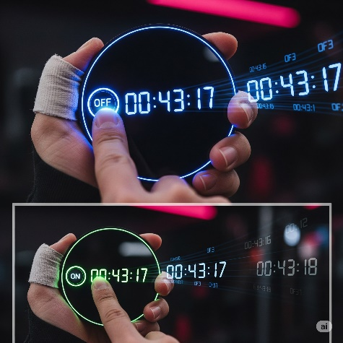

A batching machine that must complete a process in stages. If input signal stops mid-cycle, the timer pauses. When resumed, the timer continues from previous value. Show PLC logic box and machine visuals with glowing indicators.

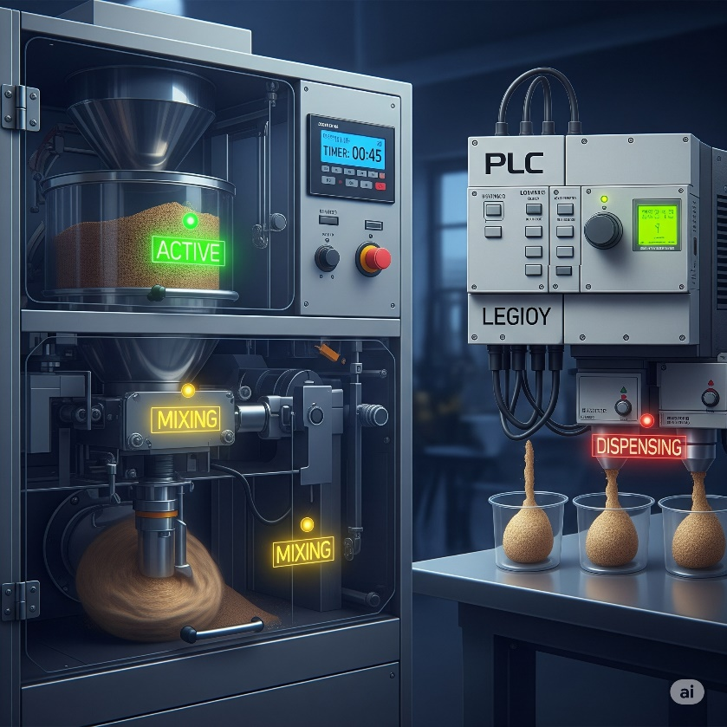

It will resume mixing and dispensing…

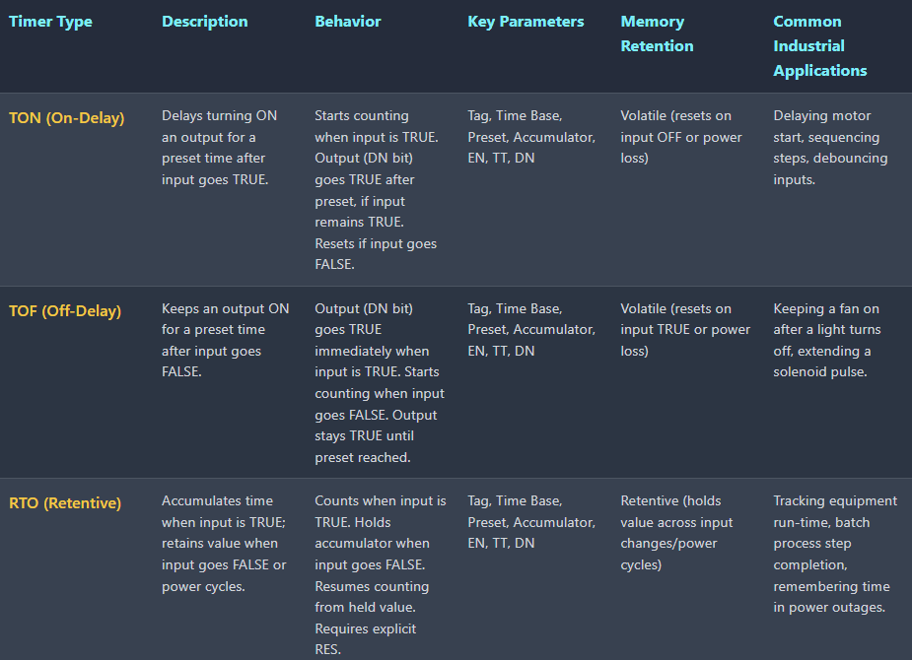

.

**🔢** EVENT-BASED CONTROL: MASTERING PLC COUNTERS

So, here’s the vibe:  
While **timers** handle *when*, **counters** handle *how many*.  
They're the go-to when you want to:

* Count products on a conveyor 🛒
* Trigger something after 5 button presses 🔘
* Batch a process after hitting a set amount 🎯
* Watch production output like a hawk 👀

**🔍** What Makes Up a Counter?

The Anatomy of a Counter

Just like timers, counters have a basic anatomy. Here is a breakdown of their key parameters. I’ll write and send in images for those who don’t read images:

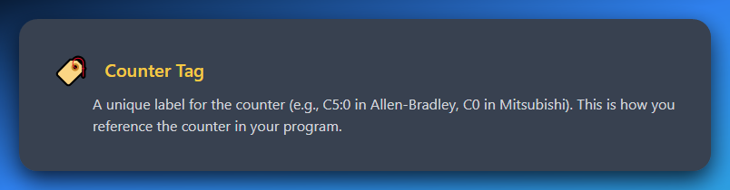

**Counter Tag:** A unique label for the counter (e.g., C5:0 in Allen-Bradley, C0 in Mitsubishi). This is how you reference the counter in your program.

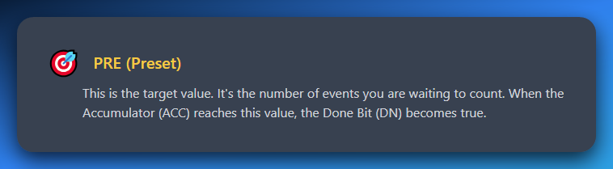

**PRE(Preset):** This is the target value. It's the number of events you are waiting to count. When the Accumulator (ACC) reaches this value, the Done Bit (DN) becomes true.

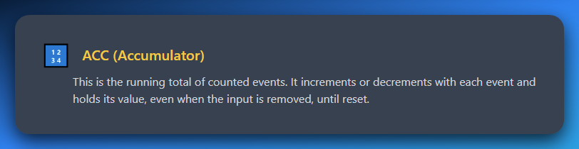

**ACC (Accumulator):** This is the running total of counted events. It increments or decrements with each event and holds its value, even when the input is removed, until reset.

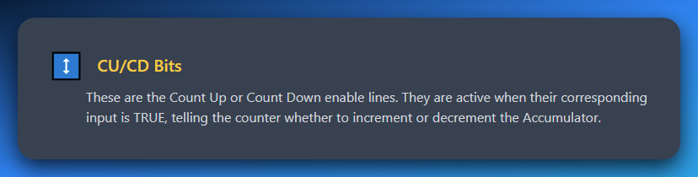

**CU/CD Bits:** These are the Count Up or Count Down enable lines. They are active when their corresponding input is TRUE, telling the counter whether to increment or decrement the Accumulator.

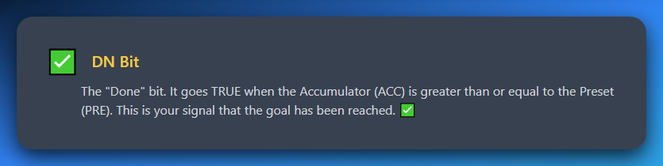

**DN Bit:** The "Done" bit. It goes TRUE when the Accumulator (ACC) is greater than or equal to the Preset (PRE). This is your signal that the goal has been reached. ✅

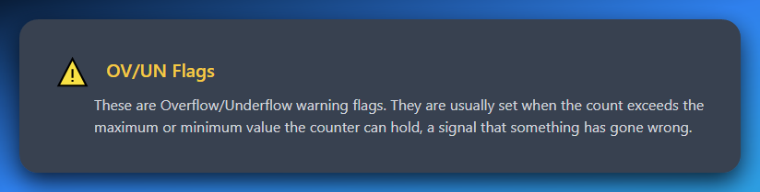

**OV/UN Flags:** These are Overflow/Underflow warning flags. They are usually set when the count exceeds the maximum or minimum value the counter can hold, a signal that something has gone wrong.

**🛠** Example in Real Life:

You want to count 100 bottles passing a sensor, then push a piston to pack them.

You’d use a **Count-Up (CTU)** counter:

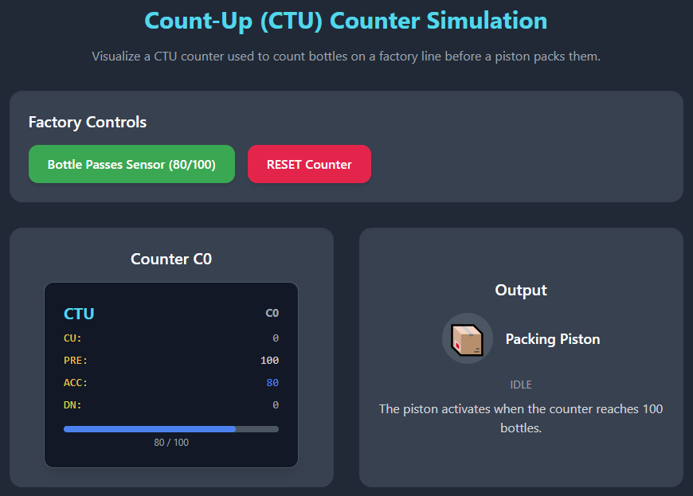

It says “Pushing” and then boom, DN becomes TRUE(1)…

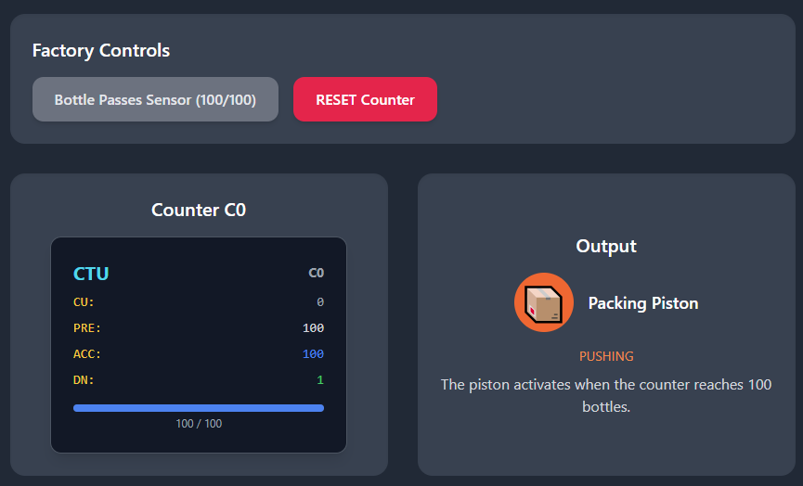

Then it returns to IDLE state till the reset counter is clicked or auto-clicked if the PLC is programmed that way.

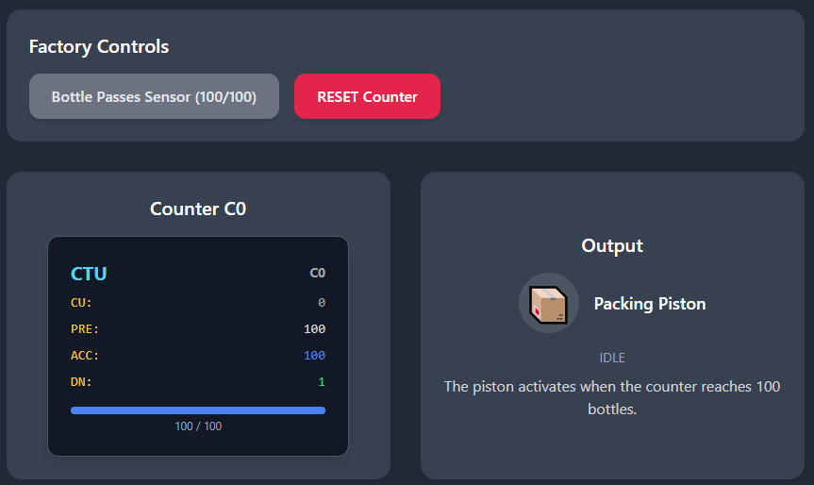

You set:

* Preset = 100.
* Every bottle triggers CU → ACC increases.
* When ACC == 100, the **DN bit** goes high → triggers piston.
* You then **reset** the counter to start the next batch.

**💡** Overflow / Underflow?

You usually won’t touch these in basic setups, but:

* **OV** = “Yo, I counted too far!” (ACC > limit)
* **UN** = “Whoa, can't go negative!” (in count-downs)

Good to keep in mind for **error handling** in critical systems.

**🔄** Summary:

* **Counters = event watchers.**
* They’re basically “if this happened X times, do Y”.
* **Preset** = your goal.
* **ACC** = your live progress bar.
* DN = your “it’s go time” flag.

**🔼** Count Up (CTU) Instruction: Count Like a Boss

**😎** What It Does:

The **CTU** (Count Up) instruction is like a tally counter.  
Every time the input changes from **OFF → ON**, it adds **1** to the total.

But wait—this isn’t just dumb counting. It’s smart.  
It watches for **rising edges** (the moment a signal *switches* ON), not just the fact that it’s ON.

**⚙️** How It Works — The Behavior:

I showed you already using the above diagram.

The Behavior of UpCounter:

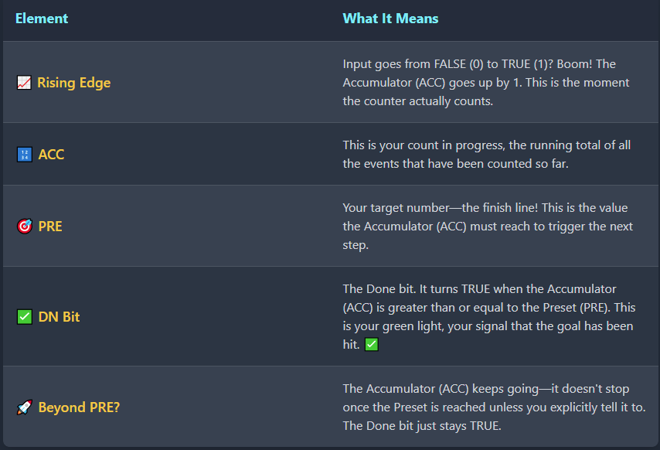

⚠️ Avoiding Double Counting — The One-Shot Hack

Sensors often remain **ON** for multiple scan cycles when detecting objects. Without proper handling, this creates a critical issue: **your accumulator (ACC) will increment multiple times for the same part**, leading to wildly inaccurate counts.

*Example: One part passes by → Sensor stays ON for 5 scan cycles → ACC increments 5 times → You think you counted 5 parts when it was actually just 1*

**The Solution: PTS (Positive Transition Sensing)**

**PTS is your safeguard against overcounting.** It works on a simple principle:

*"Only count the* ***first moment*** *this signal transitions from OFF to ON. Ignore all subsequent ON states until the signal goes OFF and back ON again."*

How PTS Works

1. **Monitors signal transitions** instead of signal states
2. **Triggers only on the rising edge** (OFF → ON transition)
3. **Ignores sustained ON signals** until the next OFF → ON cycle
4. **Ensures one-shot counting** per detection event

The Impact

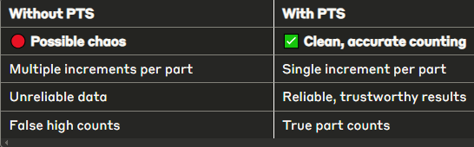

Key Takeaway

**PTS transforms continuous sensor signals into discrete counting events**, ensuring that each physical part is counted exactly once, regardless of how long the sensor remains active.

*Think of it as the difference between counting every heartbeat versus counting every person who walks by.*

**🧾** Ladder Logic Example: Counting Parts on a Conveyor

Normal state:

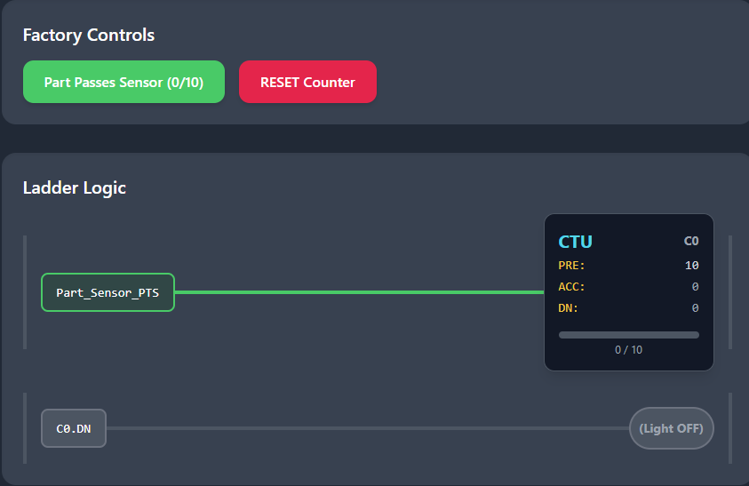

After the count:

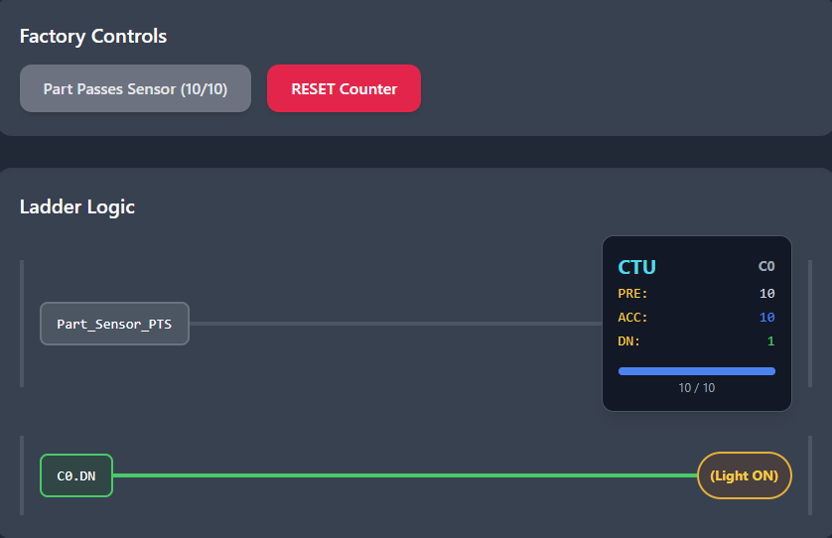

**🧠** What’s happening:

* **Part_Sensor_PTS** = One-shot pulse from sensor
* **Every time a part passes** → C0 gets +1
* **When ACC = 10** → C0.DN goes TRUE → Light turns ON

This is how factories count 10 juice bottles and send 'em to packaging.

Or 10 pizzas into a box. Or 10 screws into a bag. You get the idea.

**💬** Real Talk:

**You MUST pair your Counter (CTU) with a one-shot in high-speed or held-input scenarios.**

Here's what happens if you don't:

**Without One-Shot Protection:**

* *Part passes sensor → Sensor stays ON for 3 scan cycles*
* *Scan 1: "Input is ON! Count = 1"*
* *Scan 2: "Still ON! Count = 2"*
* *Scan 3: "Still ON! Count = 3"*
* *Result: 1 part = 3 counts* ❌

**With PTS/One-Shot:**

* *Part passes sensor → Sensor stays ON for 3 scan cycles*
* *Scan 1: "Input just turned ON! Count = 1"*
* *Scan 2: "Still ON, but I already counted this" (ignored)*
* *Scan 3: "Still ON, but I already counted this" (ignored)*
* *Result: 1 part = 1 count* ✅

**The Bottom Line:** Skip the one-shot protection and your PLC will count like an overeager kid: *"Oh it's still on? Count again! Still on? Count again! AGAIN!"*

And boom — your count is wrong, your batch fails, and someone's having a very bad day.

**PTS transforms continuous sensor signals into discrete counting events**, ensuring that each physical part is counted exactly once, regardless of how long the sensor remains active.

**🔽** Count Down (CTD): Counting in Reverse Like a Pro

**🧠** What’s the Vibe?

Think of CTD as the **reverse twin** of CTU.  
Instead of going up, we’re counting **down** every time something happens — like items being removed, tasks being undone, or lives in a game dropping (💀).

**⚙️** How CTD Works — The Behavior Rundown:

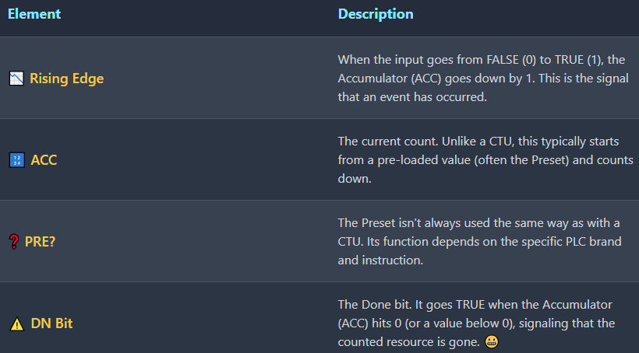

**🔧 Use Case? Inventory Depletion. Life Tracking. Countdown Before Shutdown.**

CTD is a go-to when you want to scream:

*“Yo, we’re running low on something. Time to alert the operator!”*

**🔄** One-Shot Still Matters

Just like CTU, CTD also needs to be protected by a **PTS (Positive Transition Sensing)** instruction to avoid **multiple counts per scan**.

You only want **one decrement per actual event**, not 5 for one held signal.

**🏭** Warehouse Stock Alert Simulation

A visual representation of a simple CTD counter used to track inventory.

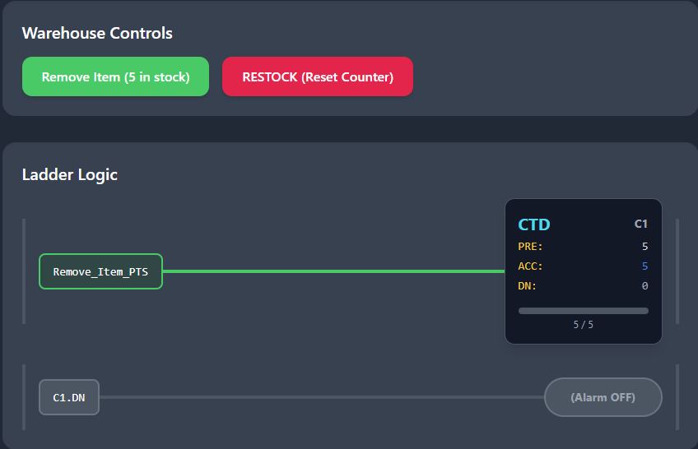

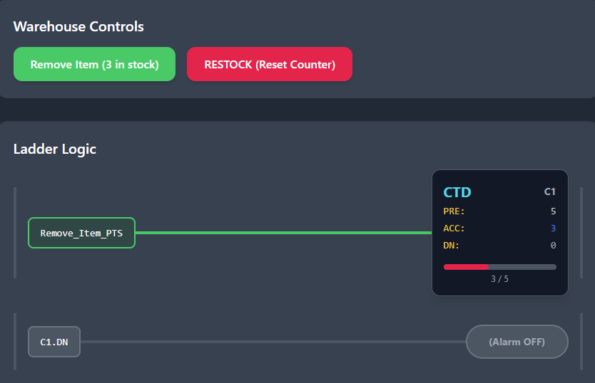

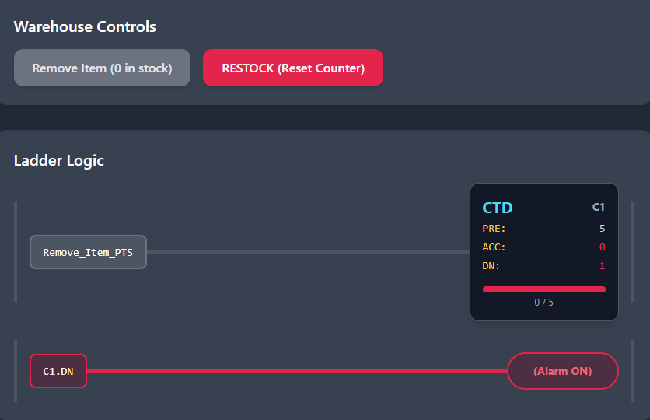

**🧠** Translation:

* C1.ACC starts at 5. Each Remove_Item_PTS pulse drops the ACC by 1
* When ACC hits 0 → C1.DN becomes TRUE → Low_Stock_Alarm goes 🔔

This could be a sensor at a storage bin counting how many items have been picked up. When it hits empty — boom — alert the crew.

**🧪** Bonus Tip: Preloading CTD Counters

You don’t normally "set" the accumulator manually in the rung.  
Instead, you **preset it** using a **MOV (Move)** instruction or **by running another logic branch** that writes a starting value into ACC before the CTD starts working.

**Example:**

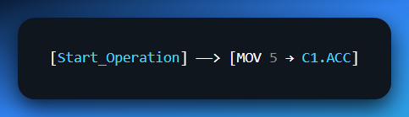

That way, the counter has something to count down *from*.

**❗** Why CTD Matters:

* You can use it to trigger restocking actions.
* It’s perfect for **error prevention** (e.g. avoid trying to fetch from empty storage).
* It works great for **maintenance cycles**, **buffer tracking**, or even **game lives** if you're doing gamified real-world systems like in casinos.

PLC counters are *underrated game dev tools* in the real world. Whether you’re tracking:

* **Tokens inserted** into a slot machine 🎰
* **Buffer level drops** between two conveyor lines 🏭
* Or **maintenance cycles** where a machine gets flagged after X uses 🛠️

...these counters shine. Just pair them with **one-shot inputs** and you're good to go! 😎

**🔁** Now: The RES Instruction — The Unsung Hero of PLC Counters

Okay fam, here's the deal:  
Counters, like stubborn old machines, **don't forget** on their own.  
They **remember** counts even when you're long gone—unless you say,

***“Yo, clear that memory!”***

That’s where **RES** comes in. It’s the digital **reset button**, and without it, your counter could act possessed.

**⚙️** RES Instruction – Core Behavior

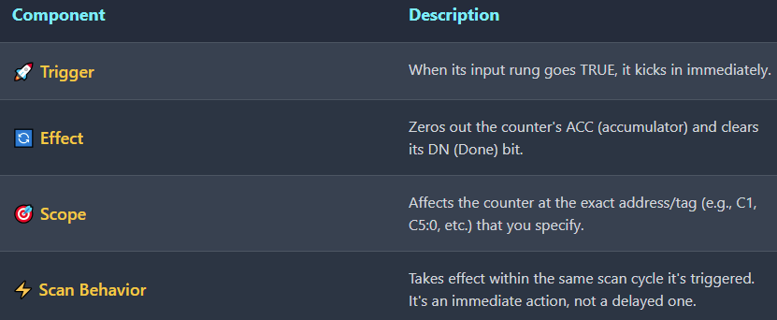

**🧠** Why It’s So Dang Important:

Without a RES:

* Your **batches never restart properly.**
* Alarms stay stuck ON (because DN is still TRUE).
* Counters **keep adding** instead of resetting, making you think you’ve produced 5000 parts... when you’ve only done 200 😬

**🧾** Ladder Logic Example:

Normal state…

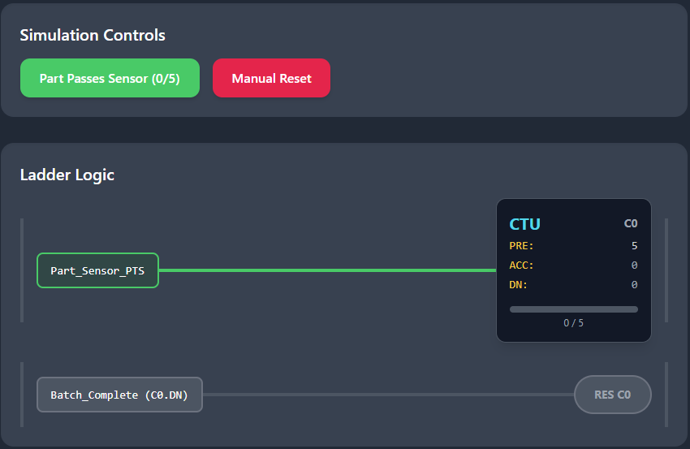

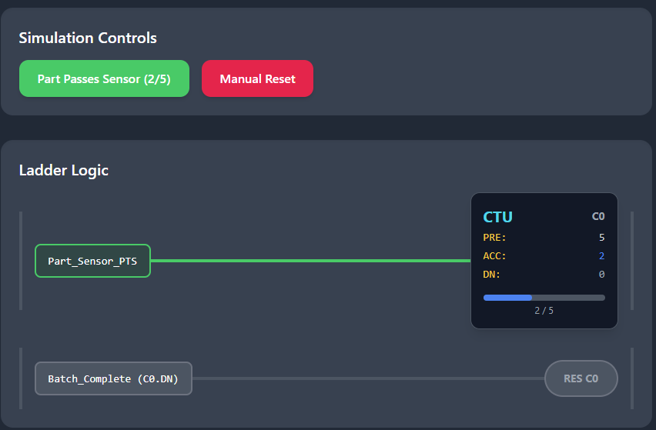

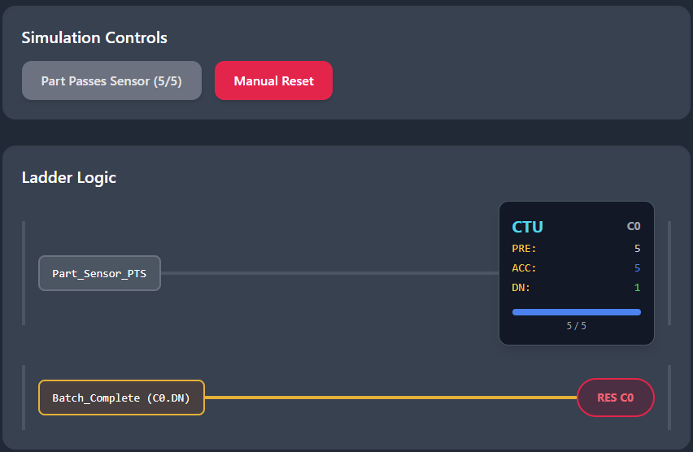

And finally, after the manual reset (RES):

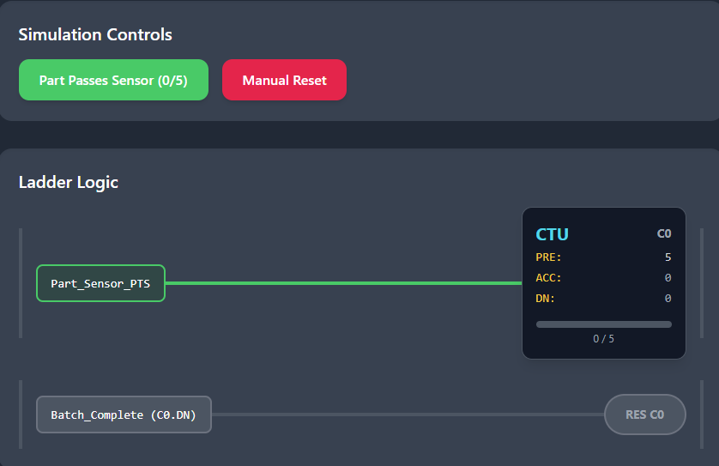

Here, when **Batch_Complete** becomes TRUE (maybe after a light or buzzer signals it's done), counter C0 gets reset and is ready for the next batch.

**⚠️** Common Mistake Alert: Counter Reset

DON'T try to reset a counter by turning off its CU or CD bit. That doesn't reset the count value — it just stops counting. Only RES explicitly clears the data.

Reset Best Practices:

* **Use one-shots to trigger the RES** — prevents continuous resetting
* **Avoid continuous TRUE conditions** or you'll keep zeroing out your counter and never actually count up/down!

Wrong Way vs Right Way:

**❌ Wrong:** Turn off CU input (counter stops but keeps its value)

**✅ Right:** Pulse the RES input (counter value goes to zero)

**💡** Real-World Example: Casino Operations

Casinos use counters extensively for automated management:

Maintenance Scheduling:

* Machine tracks **1000 spins** → triggers **maintenance alert**
* Prevents breakdowns through predictive maintenance

Promotional Systems:

* Every **10 credits used** → triggers **promo light**
* Automated customer engagement without staff intervention

Daily Reset Operations:

* At end of shift, **operator hits master reset switch**
* Runs RES on all counters simultaneously
* **Clean slate for tomorrow's operations**

This automated counting eliminates human error and ensures consistent, reliable tracking across hundreds of machines.

Key Takeaways

**PTS transforms continuous sensor signals into discrete counting events**, ensuring that each physical part is counted exactly once, regardless of how long the sensor remains active.

**Counter Reset:** Only the RES input can clear counter data — turning off CU/CD inputs just stops counting. Always use one-shot triggers for RES to avoid continuous reset conditions that prevent normal counting operations.

**🧩** Combining Timers and Counters: Real-World Control Scenarios

Timers and counters? **Deadly combo**. When you use them together, you go from basic control to *pro-level logic orchestration* — the kind that runs factories, theme parks, and yeah, even casino games if you're feeling spicy. 🎰

**🌃** 1. Batching with Time Limits

**Use case**: Ensure that X number of parts are processed **within a time limit**.

* 🔢 A **CTU counter** counts each item detected by a sensor.
* ⏱️ A **TON timer** starts when the batching begins.
* 🛑 If the timer expires **before** the count is reached, raise an alarm or stop the process.
* ✅ If the count hits preset before the timer’s done, mark the batch as complete.

**Why it matters**: Prevents processes from hanging forever waiting for missing parts.

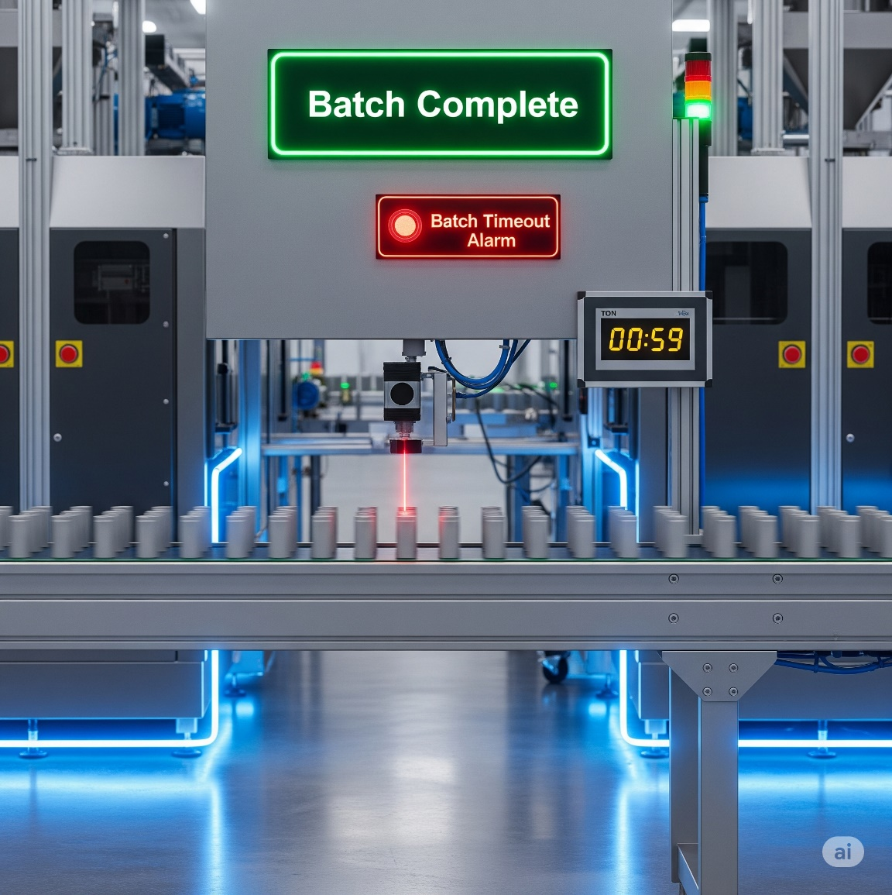

**🏭** 2. Timed Production Runs

**Use case**: Run a production line for a **set duration**, and track how many units were produced.

* ⏳ A **TON** (or **RTO**) timer controls the total run time.
* 🔢 A **CTU** counts each completed unit.
* When time’s up, stop the process — and log how many units were done in that session.

**Why it matters**: Production stats, OEE monitoring, shift-based operations.

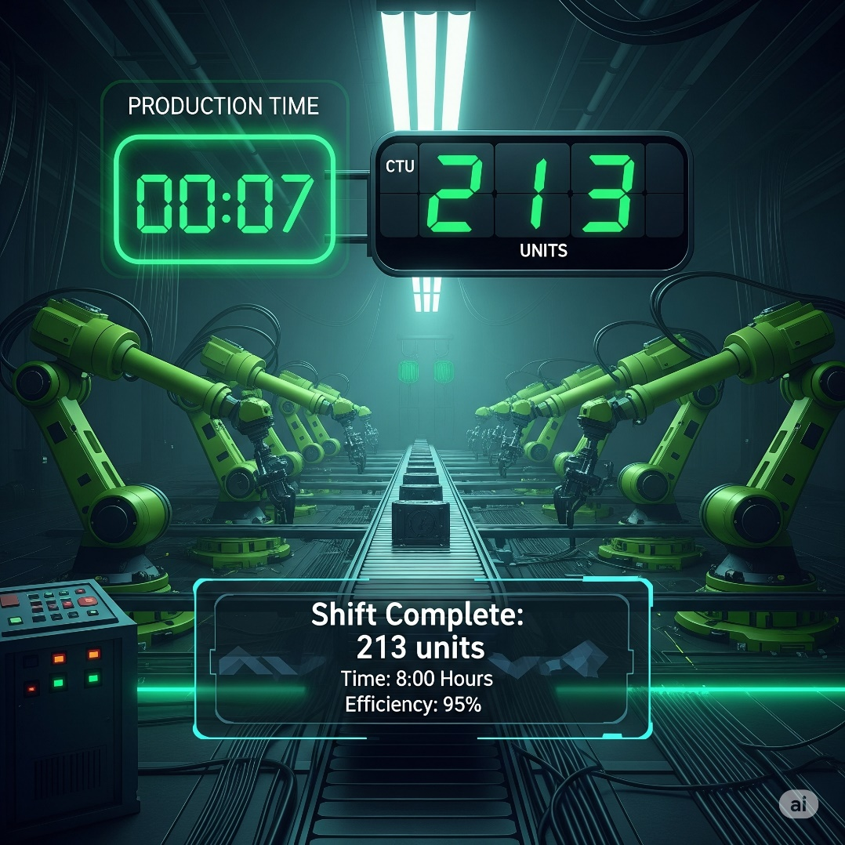

**🚚** 3. Traffic Light Control

**Use case**: Simulate timed sequences + traffic or pedestrian events.

* ⏱️ Multiple **TON** timers drive Red → Yellow → Green sequencing.
* 🔢 Optional **counters** track:
  + Number of vehicles that passed.
  + Pedestrian button presses (trigger walk sequence after 3 people?).
* Combine timers and counters for smart logic like:
  + “Only switch lights **after X cars have passed** or **Y seconds have elapsed**.”

**Why it matters**: Traffic control = real-time safety + logic sequencing under constraints.

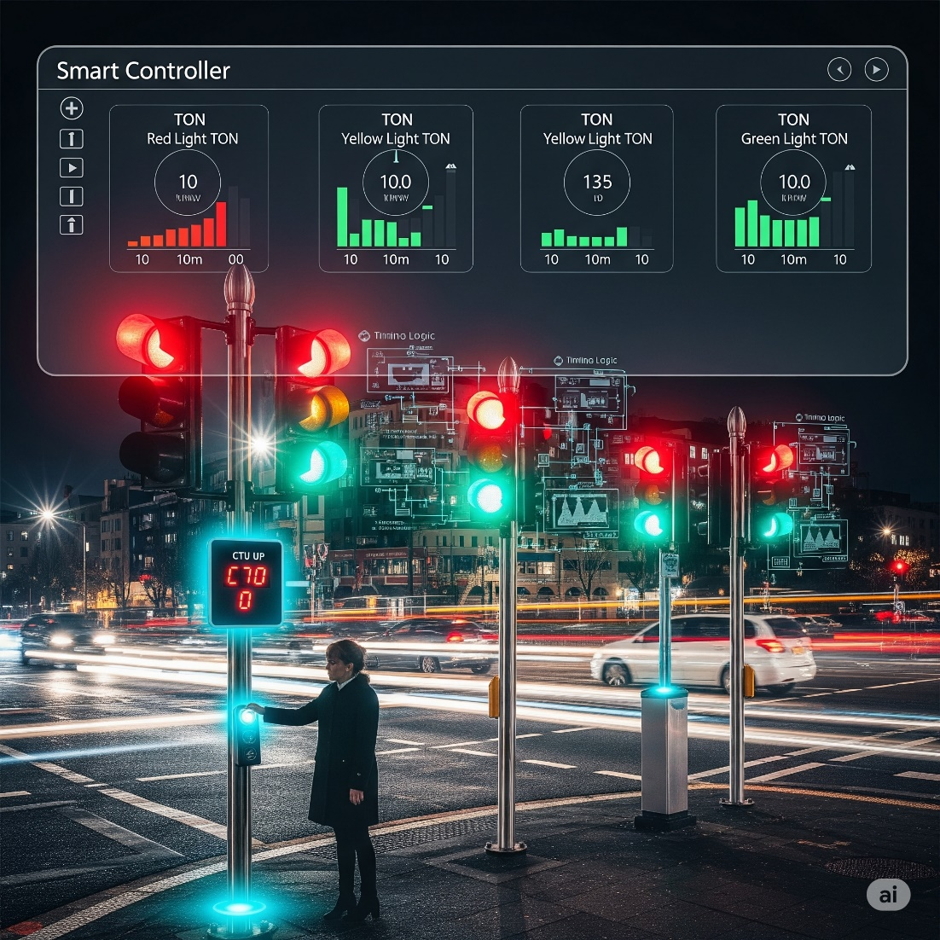

**🍾** 4. Bottle Filling & Counting

**Use case**: Precise control of filling station.

* 🥫 Sensor triggers **CTU** counter for each bottle.
* 🧴 A **TON** timer controls valve open time (e.g., 2s per bottle).
* Logic:
  + When a bottle arrives, timer activates fill valve.
  + Counter keeps track of total bottles processed.

**Bonus**: If combined with an RTO, total bottles filled this shift can be retained even if power drops!

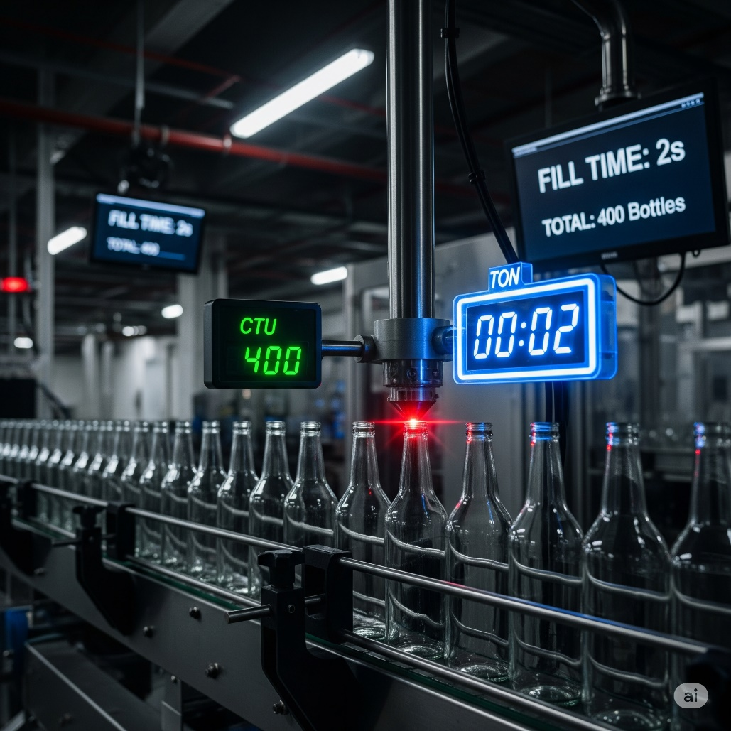

**🔥** Final Note:

Combining timers + counters = **event-based control inside a time-based framework.** It’s like scheduling + tracking — together.

We’re done with that stuff… now lets finish some missing pieces before we jump into drawing ladder logic.

**🔄** THE PLC SCAN CYCLE: MASTER CLOCK OF YOUR LOGIC WORLD

Every PLC lives and breathes through one thing: the **scan cycle**. It’s a continuous, high-speed loop that drives the logic engine — like a DJ spinning the same record, but remixing it every millisecond.

**🧠** What Happens in One Scan?

The scan cycle runs through *three phases*, always in this order:

1. **📥 Input Scan**
   * The PLC checks *every input device* (sensors, buttons, switches).
   * It stores the current ON/OFF state in internal memory.
2. **🧾 Program Execution**
   * Ladder logic is executed **top to bottom**, rung by rung.
   * The CPU uses only the *stored* input states from this scan.
3. **📤 Output Update**
   * Based on the logic results, it updates all output devices (lights, motors, solenoids).

**⏱️** How Fast Is It?

A full scan usually takes a few **milliseconds**. But even that blazing speed can cause *timing surprises*.

**🕳️** Gotchas to Watch For?

**❌ Outputs aren't instant:**  
If a button is pressed *mid-scan*, the logic doesn't “see” it until the **next** scan.

**⚡ Missed pulses:**  
If an input turns ON and OFF faster than the scan time, the PLC might **never notice it**.

💡 *This is why high-speed counter modules exist. They monitor inputs in hardware, outside of the scan cycle.*

**🔁 Volatile vs Retentive behavior:**

* OTE instructions follow the scan cycle: if the logic is FALSE, output goes OFF *that same scan*.
* But OTL, RTO, and counters? These guys **remember** their state between scans (and even power cycles if designed that way).

**📌** Why It Matters

Understanding the scan cycle helps you debug weird bugs like:

* "Why did my output flicker?"
* "Why didn’t that pulse get counted?"
* "Why is my motor still ON even though the button was released?"

The answer almost always comes back to:  
➡️ *“The scan didn’t catch it.”*

**🛠️** Pro Tip:

For high-speed or event-driven systems (e.g. 1000+ parts/min sensors), you **must**:

* Use **One-Shot triggers** (e.g., PTS / N_TRIG).
* Or upgrade to **interrupt-driven inputs or high-speed modules.**

**🧱** PROGRAM STRUCTURING TECHNIQUES: SUBROUTINES AND STATE MACHINES

As your PLC projects grow in complexity, writing logic as one long spaghetti noodle won't cut it. You need **structure** — and here’s how to build it:

**🔁** Subroutines (JSR - Jump to Subroutine)

* Think of subroutines like “functions” in Python or C.
* They’re separate blocks of logic you can “call” from your main program.
* This keeps your code clean, reusable, and easier to debug.

📌 *Example:* A subroutine for “Conveyor_Control” could be called only when System_ON is TRUE.

**🧠** State Machines (Step-by-Step Logic)

* State machines break your process into **steps**, like a flowchart.
* You use internal bits (like M1, M2, etc.) to track *which state you're in*.
* You define conditions to move from one state to the next (called “transitions”).

📊 *Bonus:* Many PLCs support **SFC (Sequential Function Charts)** — a visual, step-based programming method perfect for machines with phases (wash → rinse → spin, etc.)

**🛠️** Troubleshooting Timers, Counters, and M-Bits

Even clean code can break if something subtle’s off. Here's a battle-tested checklist:

**❌** Timers or Counters not Resetting?

* Make sure you actually used a RES instruction.
* Ensure the reset logic is TRUE at the right time.
* For retentive timers/counters, reset manually — they *don’t auto-reset*.

**🔁** Double Counting or Missed Events?

* This usually means **no one-shot**.
* Use PTS (Positive Transition Sensing) to only count *one pulse per scan*.
* If inputs are changing faster than the scan cycle, the PLC won’t catch them.

**⚠️** Outputs Not Turning On?

* Don’t assume the output's rung is true — *check live*.
* Use your PLC software’s “Monitor” mode to watch bit states in real-time.
* Look for:
  + Wrong input address?
  + OTE not energized because rung is FALSE?
  + Conflicting OTL / OTU logic?
  + Retentive memory not behaving as expected after a power cycle?

**🔍** Final Debug Pro Tips

**✅** Use **rung-by-rung stepping** to trace logic execution linearly.

**✅** Use **cross-reference tools** to find every place a bit is used.

**✅** Watch the **scan time** — for fast inputs, timing bugs are lurking.

**✅ Summary Mindset:** Stop guessing. Start *watching*. A good PLC programmer isn’t just a coder — they’re a **logic detective.**